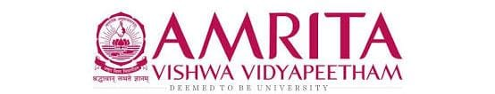

DATA STRUCUTRES AND ALGORITHMS
23CSE203
LAB MANUAL
Submitted by

Name | S.Mohitha
Roll No | AV.SC.U4CSE25039
Year/Sem/Section | 2nd year/Sem-3/CSE-A
Credits | 05

Submitted to

Name | Dr. RAJ KUMAR BATCHU
Department | School of Computing
Designation | Asst. Professor (SI Grade)

S.NO | TITLE | PAGE NO | REMARKS
1. | WEEK 1: 1a. Recursive countdown from n to Launch.  1b. Recursive calculation of compound growth factor.  1c. Recursive search for employee ID in list.  1d. Recursive factorial calculation for parcel arrangements.  1e. Recursive Fibonacci series generation. | 3 - 9
2. | WEEK 2: 2a. Python program to perform linear search on the given input.  2b. Python program to perform binary search on the given input.  2c. Verify by taking sorted array and unsorted array as an input. | 9 - 14
3. | WEEK 3: 3. Python program to perform bubble sort, insertion sort, selection sort, merge sort, quick sort on the given input. | 14 - 20
4. | WEEK 4: 4a. Python program to implement a menu-driven Singly Linked List (SLL) with the following operations:  - Create a list  - Insert at beginning/end/specific position  - Delete by value/first/last node  - Count and display nodes  - Exit  4b. Python program to implement a menu-driven Doubly Linked List (DLL) with the following operations:  - Create a list  - Insert at beginning/end/specific position  - Delete at beginning/end/specific position  - Count and display nodes  - Exit  4c. Python program to implement a menu-driven Circular Linked List (CLL) with the following operations:  - Create a list  - Insert at beginning/end/specific position  - Delete at beginning/end/specific position  - Count and display nodes  - Display head and tail  - Exit | 20 - 34
5. | WEEK 5: 5. Write a python program to implement a stack using an Array, Linked list. Implement the stack operations such as push, pop, peak and also display the stack elements. | 34 – 39
6. | WEEK 6: 6. Write a python program to implement queue and its operations such as enqueue, dequeue, peek, display with a menu driven approach implement using array, linked list, circular linked list. | 39 – 46

WEEK – 1
1a. AIM: A rocket launch system displays a countdown before launch. Instead of using a loop, implement the countdown using recursive. Write a recursive python program to display a countdown from n to 1, followed by “Launch”.
PROGRAM:
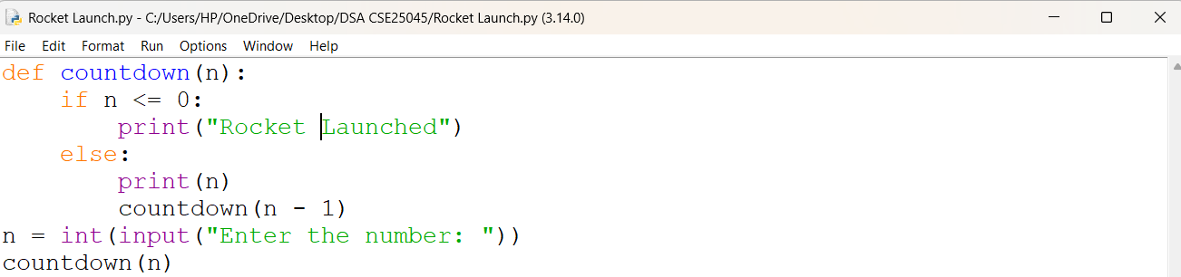
OUTPUT:
Positive Case;
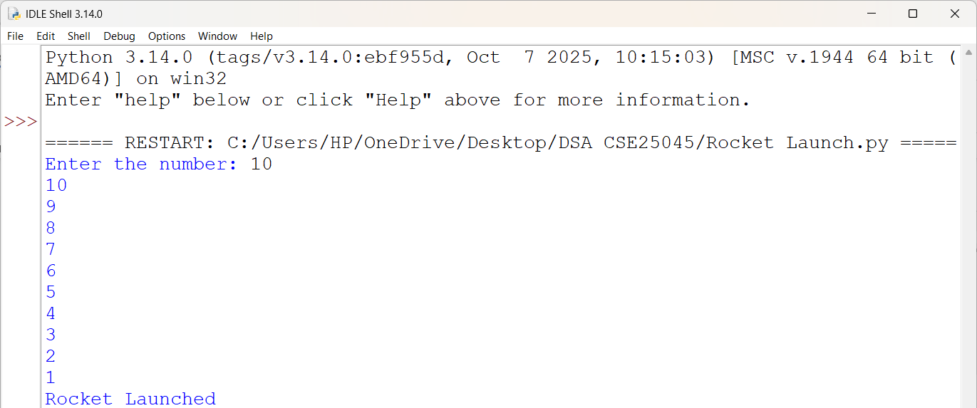
Negative Case;
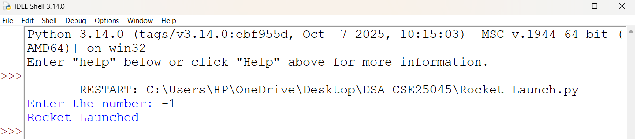

EXPLANATION:
- It takes a number as input from the user and stores it in n.
- It creates a recursive function named countdown() that prints the countdown.
- If n is greater than 0, it prints the current value and calls countdown(n - 1) to continue the countdown.
- When n becomes 0 or less, it prints "Rocket Launched" and stops the recursion.
- Finally, it starts the recursive countdown by calling countdown(n).

ERROR TABLE:
S.NO | Error Obtained | Rectification
1. | Syntax Error  Forgot to give the ":" after the if, else, or function definition. | It was rectified by adding the missing ":".
2. | Value Error  Entered a non-integer value instead of an integer. | It was rectified by entering only integer values as input.

1b. AIM: Banks calculate the growth of an investment using compound interest. The formula requires calculating powers, which can be implemented recursively. Write a recursive program to calculate P^{n}(power), Where p = principal growth factor, n = number of years.
PROGRAM:
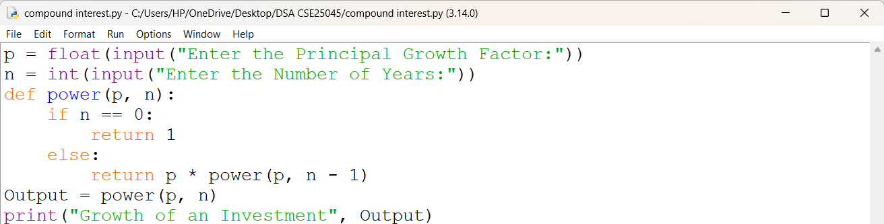

OUTPUT:
Positive Case;
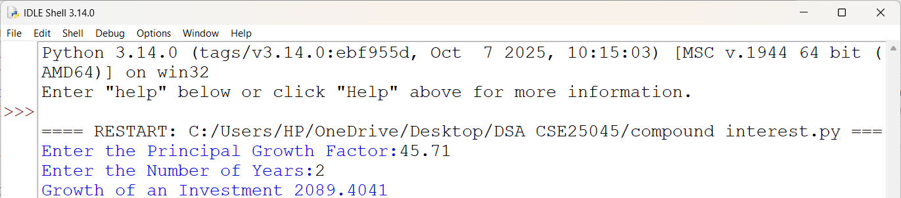
Negative Case;
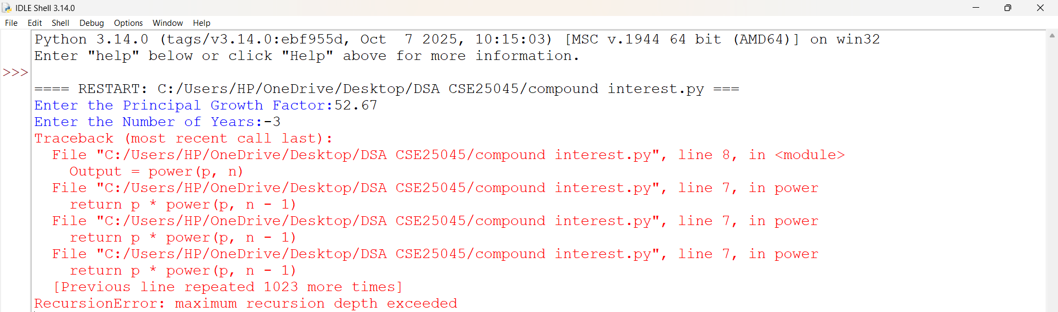

EXPLANATION:
- The program accepts the growth factor p and the number of years n as input and calls the recursive function power(p, n).
- The function checks the base case if n == 0; if true, it returns 1, since any number raised to the power 0 is 1.
- If n > 0, the function recursively computes the result by returning p * power(p, n - 1) until the base case is reached.
- If n < 0, the recursive calls continue indefinitely because the base case is never satisfied, resulting in a Recursion Error.
- Finally, for valid non-negative inputs, the program displays the value of pⁿ, representing the growth factor raised to the given number of years.

ERROR TABLE:
S.NO | Error Obtained | Rectification
1. | Invalid Input Error  I entered a floating-point value instead of an integer for the number of years. | It was rectified by entering an integer value.
2. | Large Input Error  I entered a very large value for the number of years. | It was rectified by entering a smaller input value within Python's recursion limit.

1c. AIM: An HR department stores employee IDs in a list. Develop a recursive program to search for a given employee ID. Write a recursive function to search for an employee ID in a list.
PROGRAM:
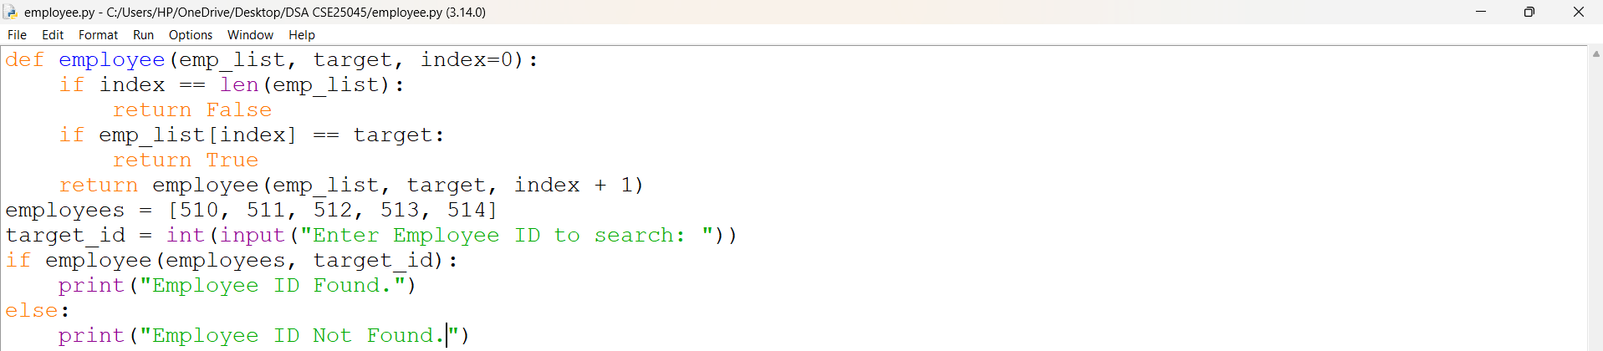
OUTPUT:
Positive Case and Negative Case;

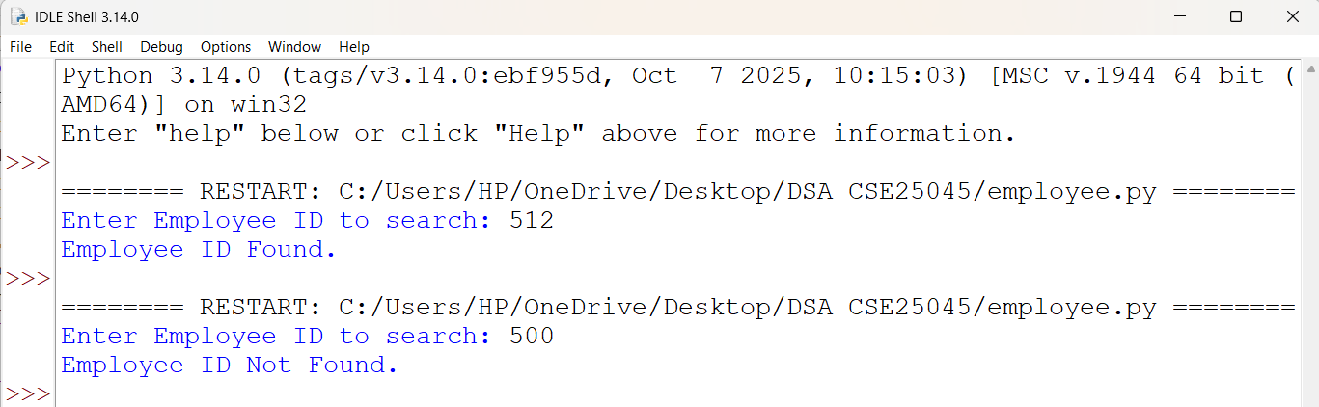

EXPLANATION:
- The program accepts the Employee ID as input and invokes the recursive function search_employee(emp_list, target, index) with the initial index set to 0.
- The function compares emp_list[index] with the target Employee ID. If they are equal, it returns True, terminating the recursion.
- If no match is found, the function recursively calls itself with index + 1 to search the next element in the list.
- The base case is reached when index == len(emp_list), indicating that all elements have been searched. The function then returns False.
- Based on the returned Boolean value, the main program displays either "Employee ID Found ." or "Employee ID Not Found.".

ERROR TABLE:
S.NO | Error Obtained | Rectification
1. | List Initialization Error  I have not entered any Employee IDs in the list. | It was rectified by adding the required Employee IDs to the list before performing the search.
2. | Index Error  I tried to access an index beyond the size of the list. | It was rectified by checking the base condition before accessing the list element.

1d. AIM: In a logistics company, the number of possible ways to arrange n different parcels is calculated using the factorial formula (n!). Develop a recursive program to calculate the factorial of a given number.
PROGRAM:
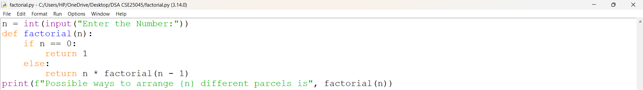
OUTPUT:
Positive Case;
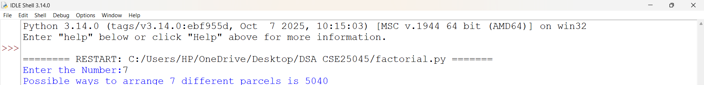
Negative Case;
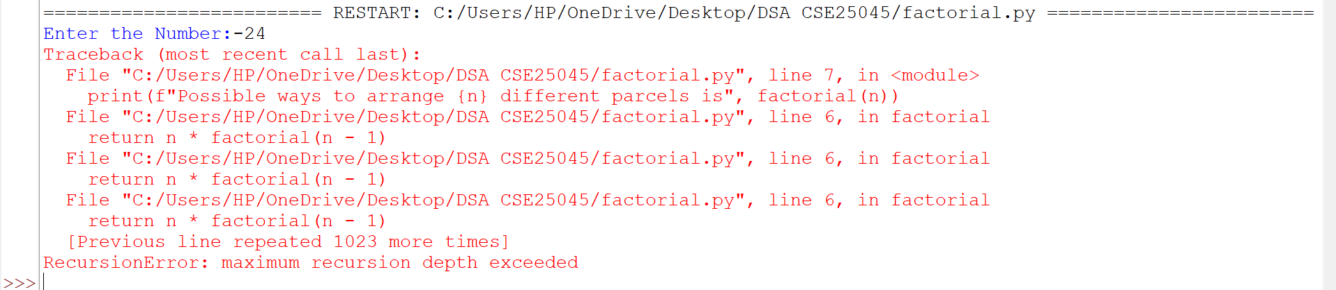
EXPLANATION:
- The program accepts an integer n as input and calls the recursive function factorial(n).
- The function checks the base case if n == 0; if true, it returns 1, since 0! = 1.
- If n > 0, the function recursively calls factorial(n - 1) and returns n * factorial(n - 1) to compute the factorial.
- The recursion continues until the base case is reached, after which the recursive calls return the final factorial value.
- Finally, the program displays the total number of possible arrangements (n!) for the given number of parcels.

ERROR TABLE:
S.NO | Error Obtained | Rectification
1. | Negative Input Error  I entered a negative integer as input. | It was rectified by entering a non-negative integer (n ≥ 0).
2. | Name Error  I called the function with an incorrect function name. | It was rectified by using the correct function name factorial().

1e. AIM: Write a recursive python program to print the first n terms of the Fibonacci Series.
PROGRAM:
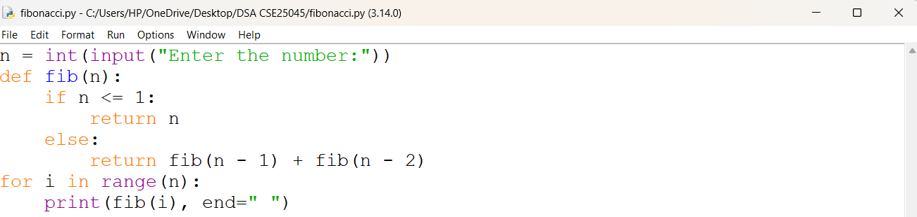
OUTPUT:
Positive Case;
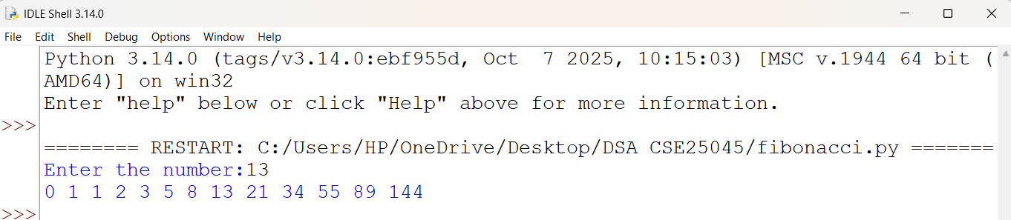
Negative Case;

EXPLANATION:
- The program accepts an integer n as input and calls the recursive function fib(n).
- The function checks the base case if n <= 1; if true, it returns n, representing the first two Fibonacci numbers (0 and 1).
- If n > 1, the function recursively computes the Fibonacci number by returning fib(n - 1) + fib(n - 2).
- The recursion continues until the base case is reached, after which the recursive calls return and calculate the required Fibonacci number.
- Finally, the program displays the Fibonacci number corresponding to the given position n.

ERROR TABLE:
S.NO | Error Obtained | Rectification
1. | Negative Input Error  I entered a negative integer as input. | It was rectified by entering a non-negative integer (n ≥ 0).
2. | Large Input Error  I entered a very large number. | It was rectified by entering a smaller input value.

WEEK – 2
2a. AIM: Write a python program to perform linear search on the given input.
PROGRAM:
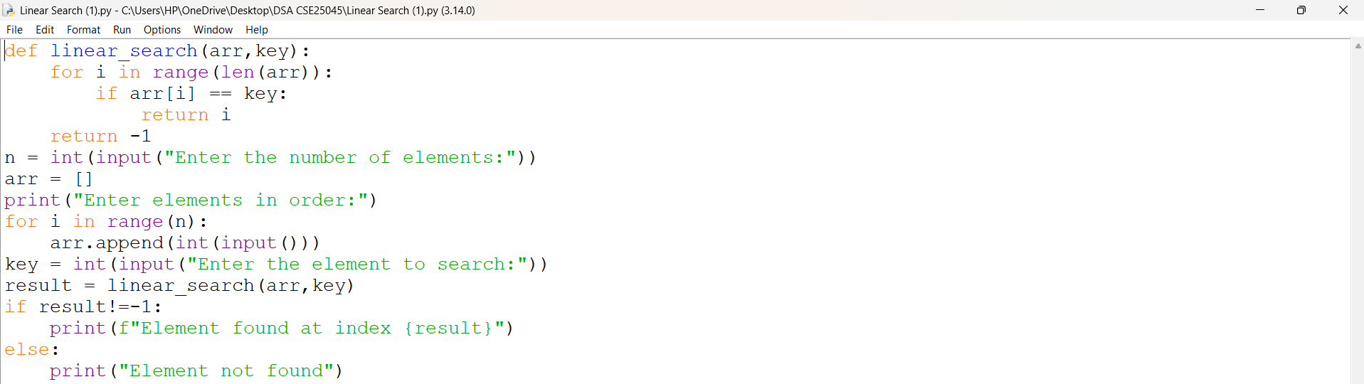
OUTPUT:
Positive Case;
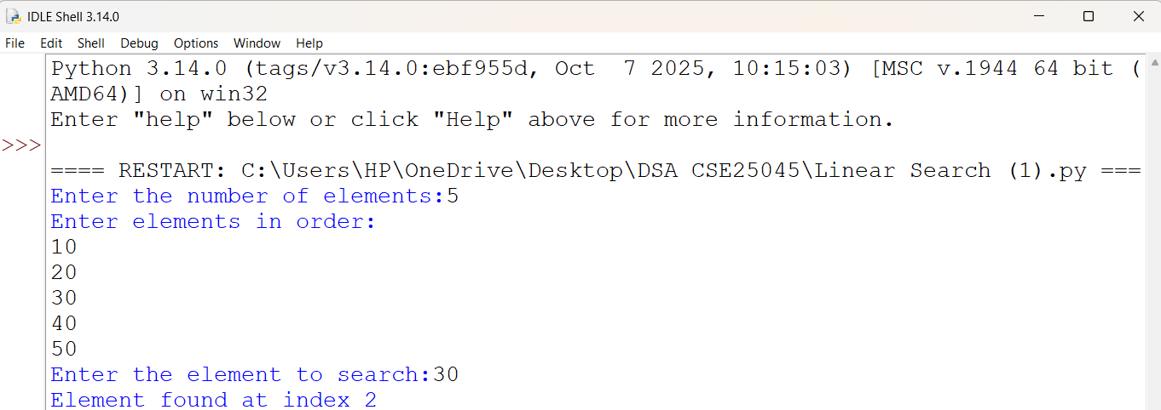

Negative Case;
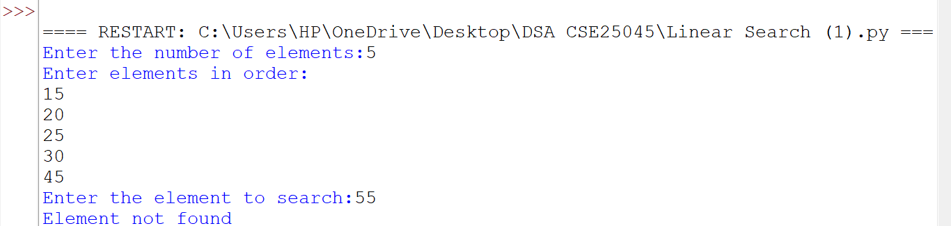
EXPLANATION:
- The program implements Linear Search to find a specific element in an array.
- It first asks the user to enter the number of elements and stores them in a list.
- The linear_search() function checks each element of the array one by one.
- If the result is not -1, it displays "Element found at index".
- If the result is -1, it displays "Element not found".
- Thus, the program demonstrates both successful (positive) and unsuccessful (negative) linear search cases.

ERROR TABLE:
S.NO | Error Obtained | Rectification
1. | Search Element Not Found: The entered element was not present in the array. | Search Element Not Found: The entered element was not present in the array.
2. | Wrong Search Result: The program was given an incorrect search element. | Re-entered the correct element to be searched.

2b. AIM: Write a python program to perform binary search on the given input.
PROGRAM:
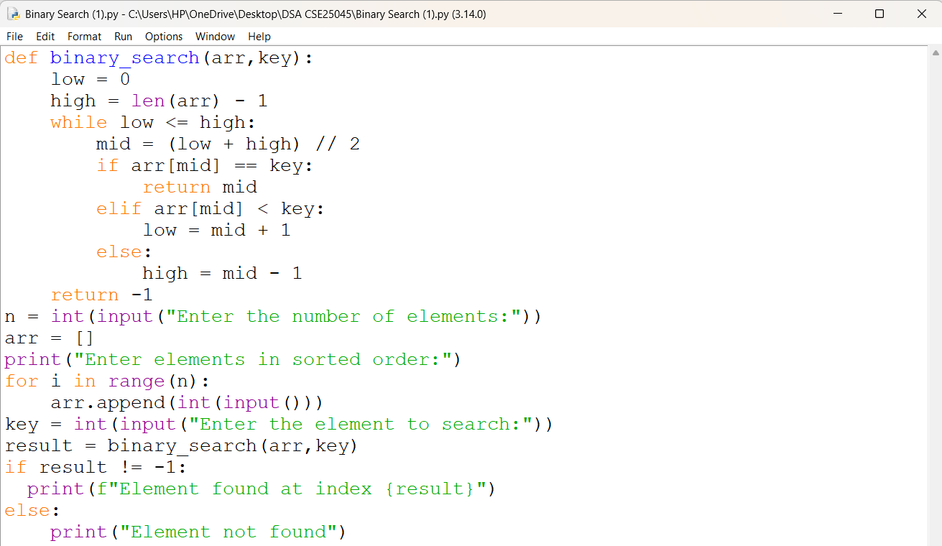
OUTPUT:
Positive Case;
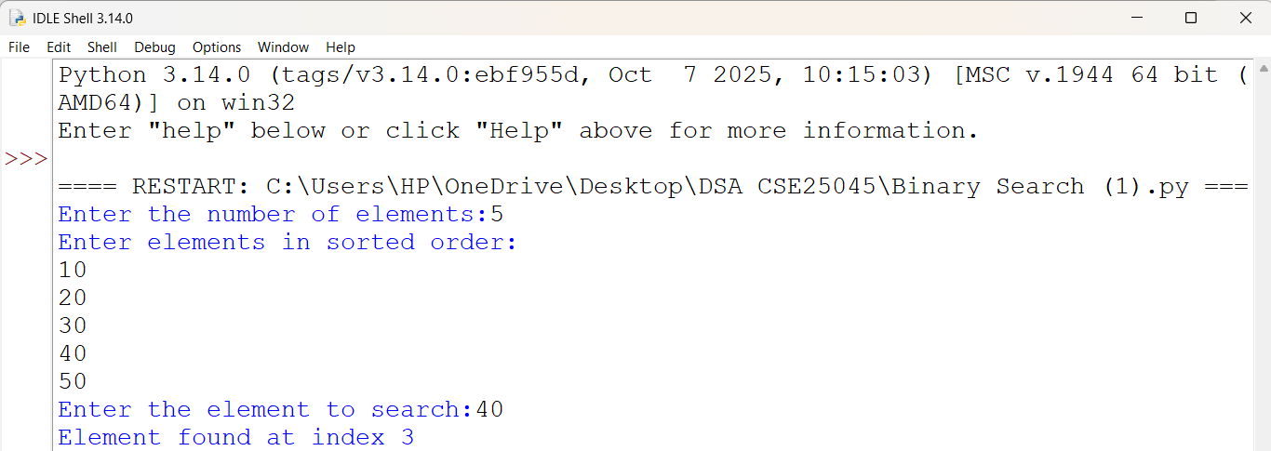
Negative Case;
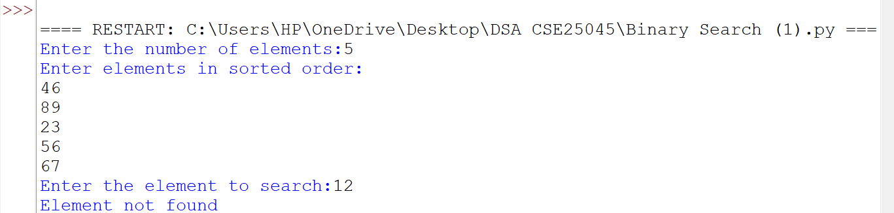

EXPLANATION:
- The program defines a binary_search() function to search for a key in a sorted arr.
- It initializes low as 0 and high as len(arr) - 1.
- The while low <= high loop calculates the mid index using (low + high) // 2.
- If arr[mid] == key, the mid index is returned.
- If arr[mid] < key, low is updated to mid + 1; otherwise, high is updated to mid - 1.
- If the key is not found, the function returns -1 and the program displays "Element not found".
ERROR TABLE:
S.NO | Error Obtained | Rectification
1. | Unsorted Array: Binary search gave an incorrect result when the elements were not in sorted order. | Entered the elements in ascending order before performing the search.
2. | Incorrect Search Range: The low and high values were not updated correctly after comparing with arr[mid]. | Updated low = mid + 1 for the right half and high = mid - 1 for the left half.

2c. AIM: Verify by taking sorted array and unsorted array as an input.
PROGRAM:
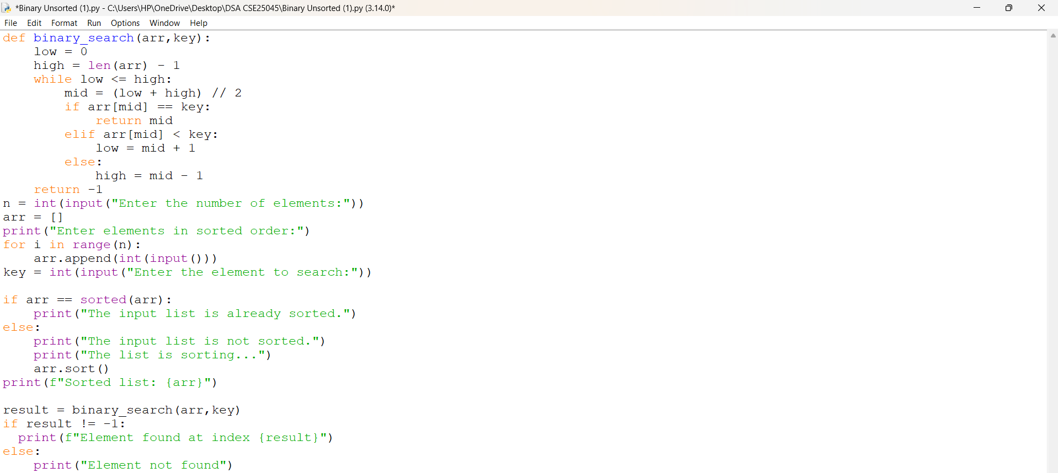
OUTPUT:
Sorted Array;
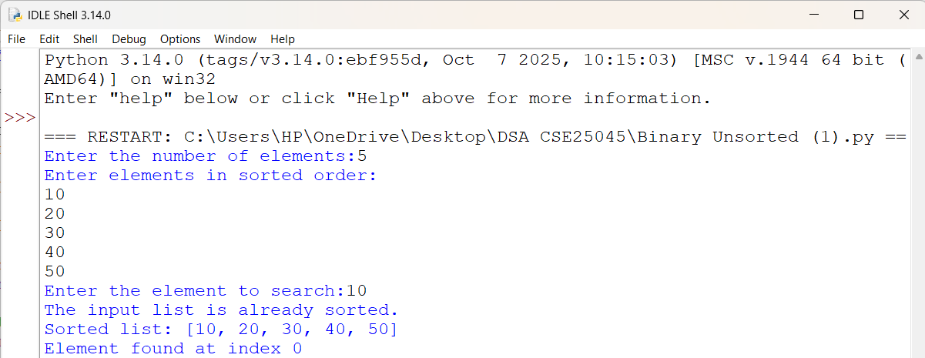
Unsorted Array;
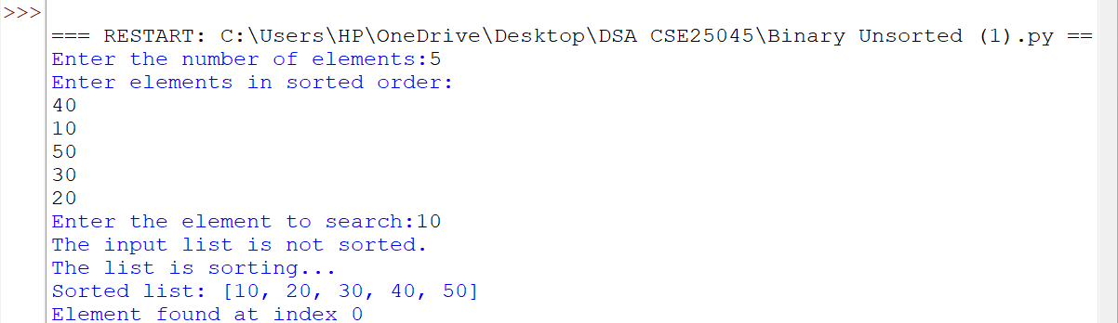
EXPLANATION:
- The program defines a binary_search() function to search for a key in an array using Binary Search.
- It initializes low and high and calculates the mid index to compare the middle element with the key.
- It checks whether arr == sorted(arr) to determine if the input list is already sorted.
- If the list is not sorted, arr.sort() sorts the elements before performing the search.
- The binary_search() function searches the sorted arr and returns the index if the key is found, otherwise it returns -1.
- Finally, the program displays whether the element is found or not found.

ERROR TABLE:
S.NO | Error Obtained | Rectification
1. | Unsorted Array: The input elements were entered in an unsorted order. | Used arr.sort() to arrange the elements in ascending order before binary search.
2. | Incorrect Sorted Order: The elements were not arranged in the required ascending order for binary search. | Checked the list using arr == sorted(arr) and sorted it when required.

WEEK – 3
3a. AIM: Write a python program to sort the elements using a bubble sort technique. Take the input elements from the user.
PROGRAM:
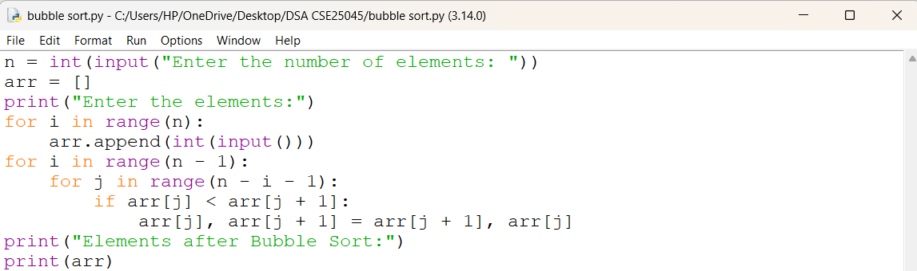
OUTPUT:
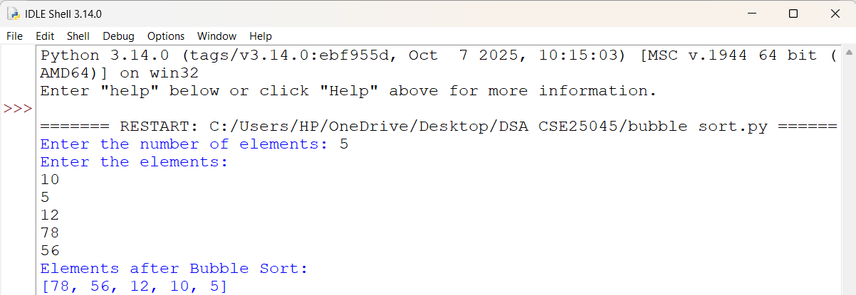
EXPLANATION:
• n = int(input(...)) – Gets the number of elements.
• arr = [] – Creates an empty list to store elements.
• for i in range(n) – Takes n elements as input.
• arr.append(...) – Adds each element to arr.
• for i in range(n - 1) – Performs Bubble Sort passes.
• for j in range(n - i - 1) – Compares adjacent elements.
• if arr[j] < arr[j + 1] – Checks if the current element is smaller.
• arr[j], arr[j + 1] = ... – Swaps the elements to sort in descending order.
• print(arr) – Displays the sorted list.
ERROR TABLE:
S.NO | Error Obtained | Rectification
1. |  | Use if arr[j] < arr[j + 1]: for descending order.
  Sorting Order Error – Using > instead of < in the if condition changes the order to ascending.

3b. AIM: Write a python program to sort the elements using a insertion sort technique. Take the input elements from the user.
PROGRAM:
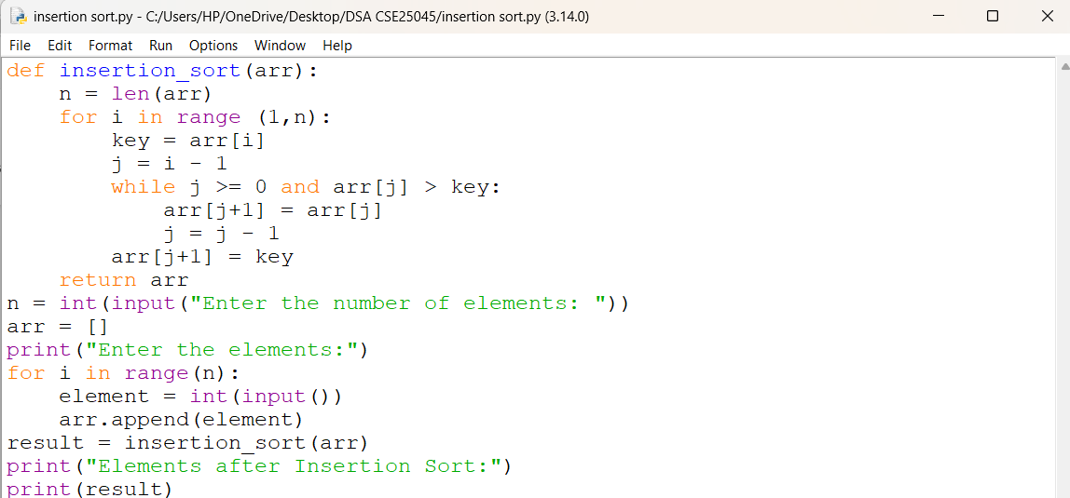
OUTPUT:
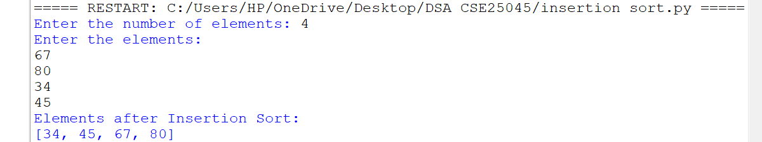
EXPLANATION:
• n = len(arr) – Gets the list size.
• for i in range(1, n) – Selects elements from the second position.
• key = arr[i] – Stores the current element.
• j = i - 1 – Sets the previous index.
• while j >= 0 and arr[j] > key – Compares previous elements with key.
• arr[j + 1] = arr[j] – Shifts larger elements right.
• arr[j + 1] = key – Inserts key in the correct position.
• return arr – Returns the sorted list.
• result = insertion_sort(arr) – Calls the function.
• print(result) – Displays the sorted list.
ERROR TABLE:
S.NO | Error Obtained | Rectification
1.
  Insertion Error – Placing key at the wrong index.
  Use arr[j + 1] = key after shifting elements.
2. |  | Pass the input list arr to the function.
  Function Call Error – Not calling insertion_sort(arr) correctly.

3c. AIM: Write a python program to sort the elements using a selection sort technique. Take the input elements from the user.
PROGRAM:
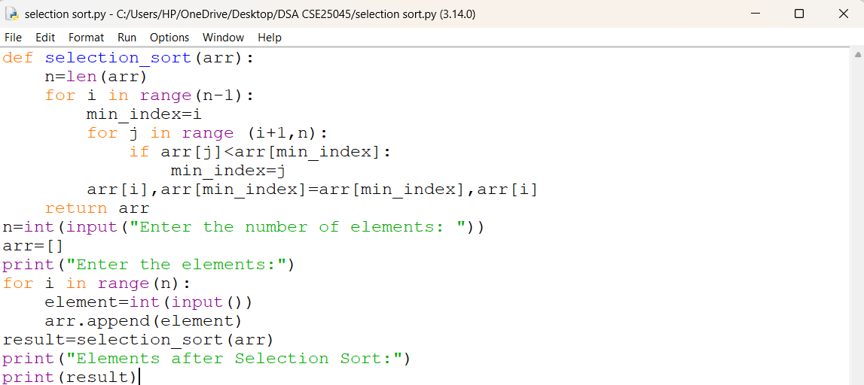
OUTPUT:
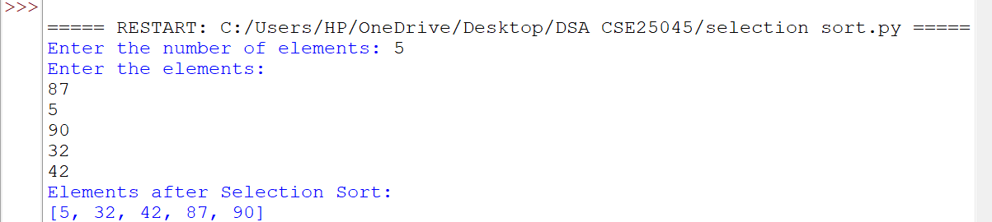
EXPLANATION:
• def selection_sort(arr) – Defines the Selection Sort function.
• n = len(arr) – Gets the number of elements in arr.
• for i in range(n-1) – Performs sorting passes.
• min_index = i – Assumes the first element is the smallest.
• for j in range(i+1,n) – Checks the remaining elements.
• if arr[j] < arr[min_index] – Finds the smallest element.
• arr[i], arr[min_index] = ... – Swaps the smallest element into position.
• return arr – Returns the sorted list.
• result = selection_sort(arr) – Calls the function.
• print(result) – Displays the sorted list in ascending order.
ERROR TABLE:
S.NO | Error Obtained | Rectification
1. | Minimum Index Error – Incorrectly assigning min_index. | Use min_index = i.
2. | Swap Error – Incorrectly swapping the elements. | Use arr[i], arr[min_index] = arr[min_index], arr[i].

3d. AIM: Write a python program to sort the elements using a merge sort technique. Take the input elements from the user.
PROGRAM:
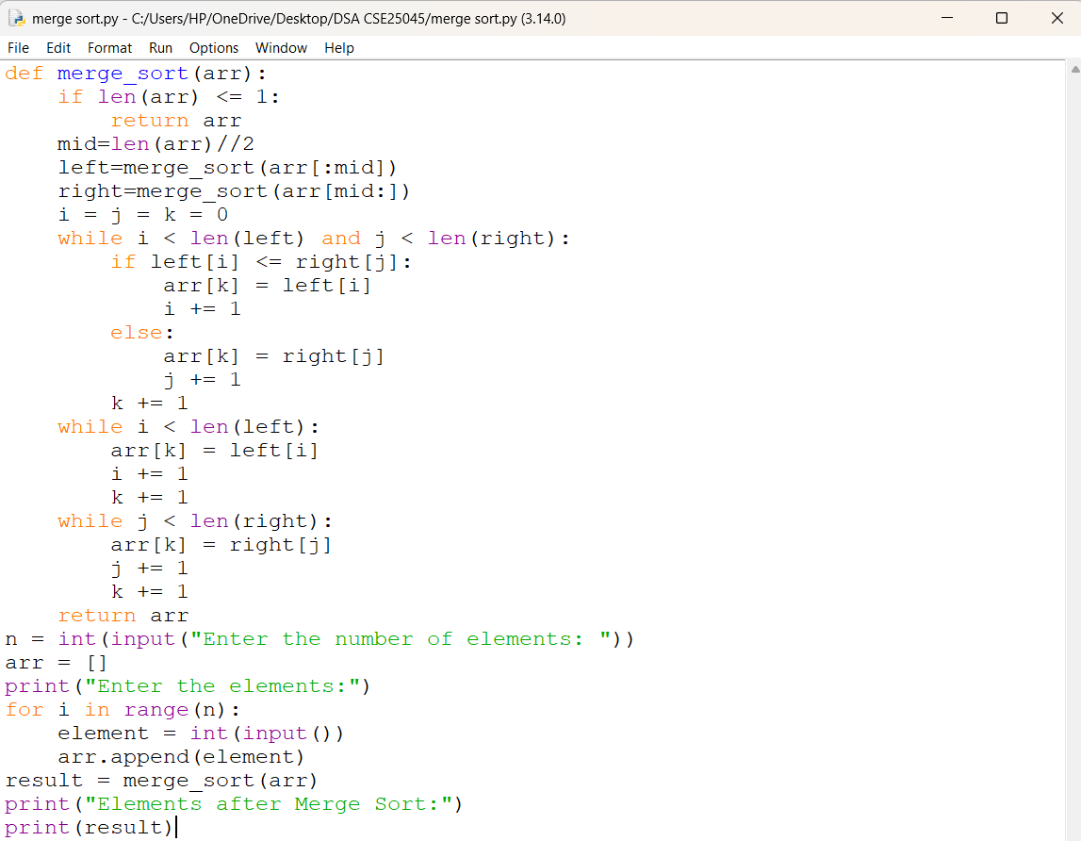
OUTPUT:
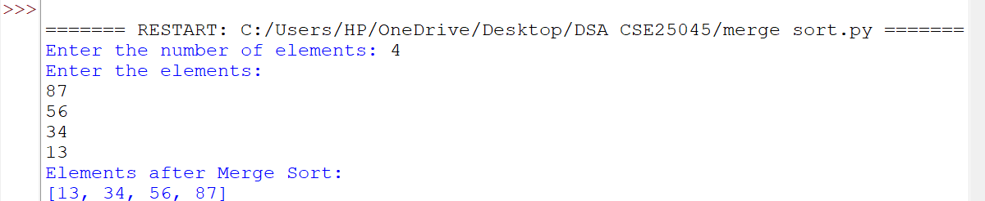
EXPLANATION:
• def merge_sort(arr) – Defines the Merge Sort function.
• if len(arr) <= 1 – Stops when the list has one or no elements.
• mid = len(arr)//2 – Finds the middle of the list.
• left and right – Divide the list into two halves recursively.
• i = j = k = 0 – Initializes the indexes.
• while loops – Compare and merge the elements.
• if left[i] <= right[j] – Selects the smaller element.
• arr[k] – Places the selected element in the list.
• return arr – Returns the sorted list.
• print(result) – Displays the sorted list.
ERROR TABLE:
S.NO | Error Obtained | Rectification
1. |  | Use arr[:mid] and arr[mid:].
  Recursion Error – Incorrectly dividing the list.
2. | Index Error – Incorrectly updating i, j, or k. | Increment the appropriate index after each insertion.

3e. AIM: Write a python program to sort the elements using a quick sort technique. Take the input elements from the user.
PROGRAM:
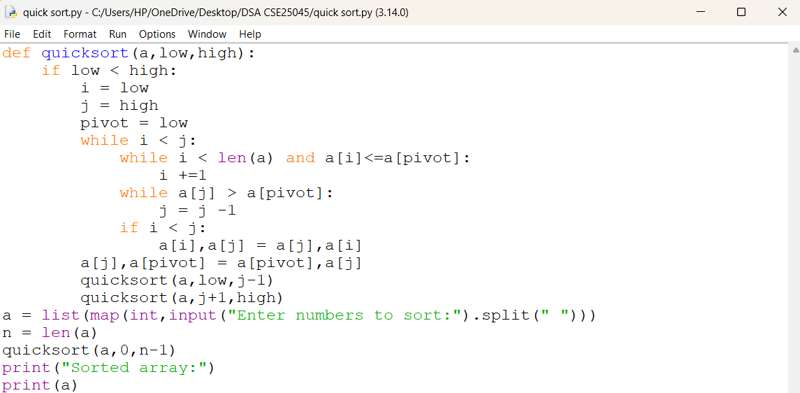
OUTPUT:
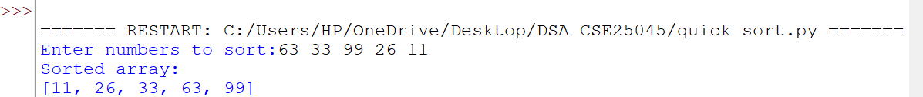
EXPLANATION:
• def quicksort(a, low, high) – Defines the Quick Sort function.
• if low < high – Checks the sorting range.
• i and j – Set left and right positions.
• pivot = low – Selects the first element as pivot.
• while i < j – Performs partitioning.
• Inner while loops – Find elements for swapping.
• a[i], a[j] = ... – Swaps elements.
• a[j], a[pivot] = ... – Places the pivot correctly.
• quicksort() calls – Sort the two partitions.
• input().split() – Takes space-separated numbers.
• print(a) – Displays the sorted array.
ERROR TABLE:
S.NO | Error Obtained | Rectification
1. | Pivot Error – Incorrectly selecting the pivot index. | Use pivot = low.
2. | Swap Error – Incorrect swapping of a[i] and a[j]. | Use a[i], a[j] = a[j], a[i].

WEEK – 4
4a. AIM: Write a python program to implement a SLL which could perform the below operations by taking an input from the user.
1) create a LL
2) Insert at beginning
3) Insert at the end
4) Insert at specific position
5) delete by value
6) delete first node
7) delete last node
8) Count no. of nodes
9) display / traverse
10) exit
PROGRAM:
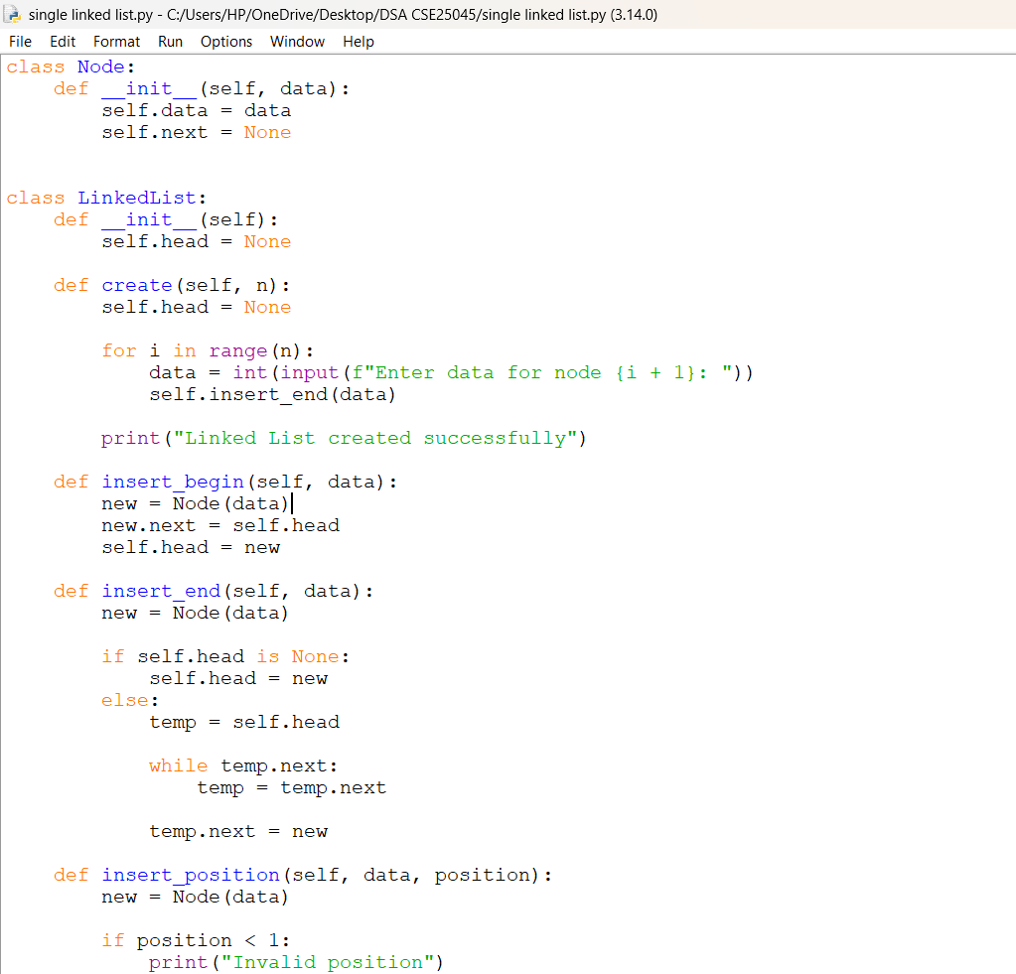
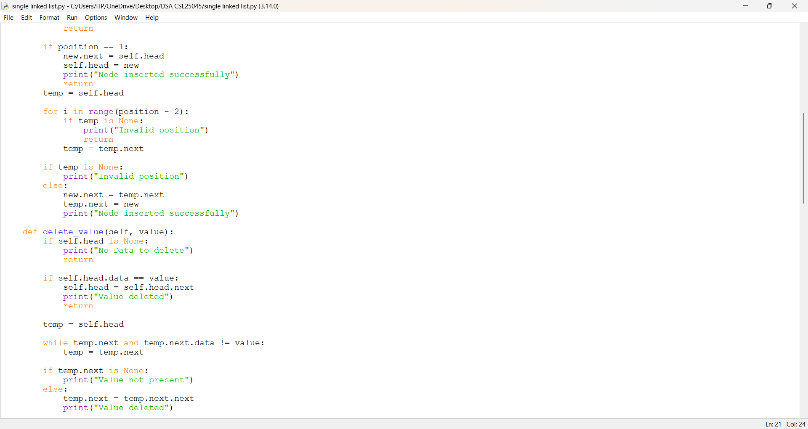
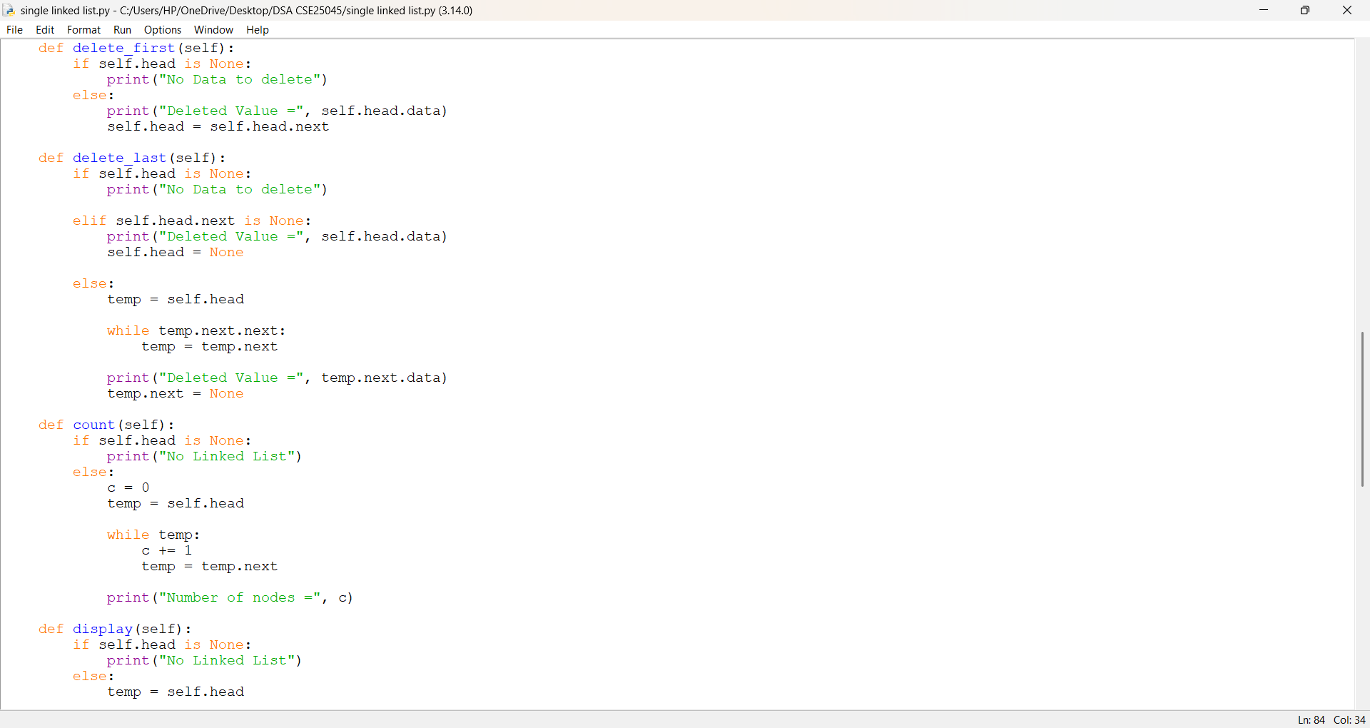
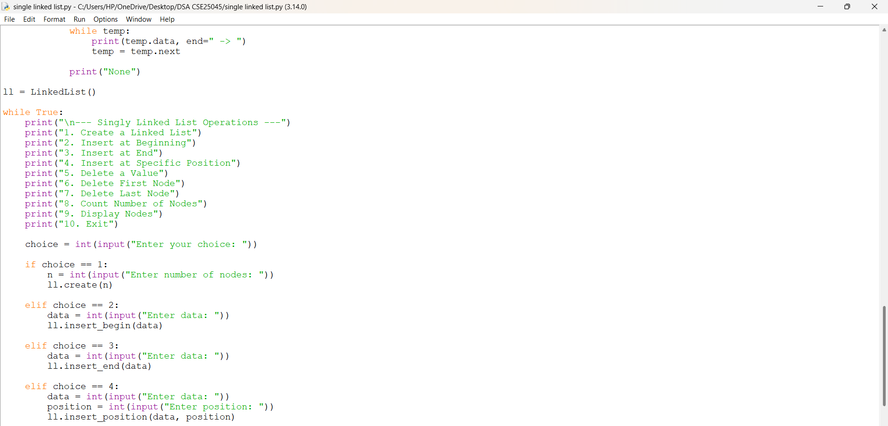
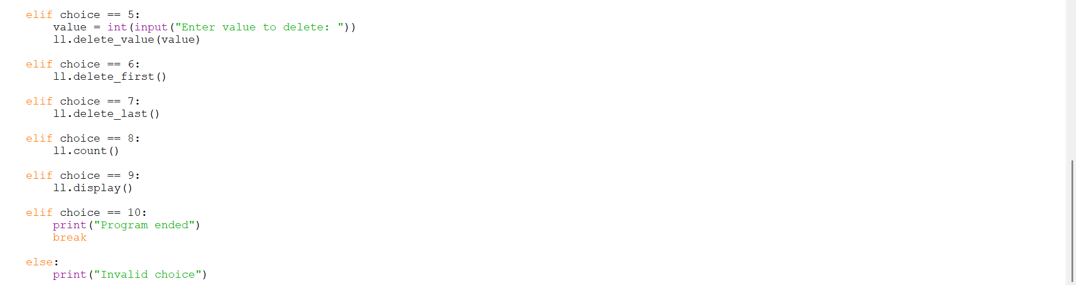
OUTPUT:
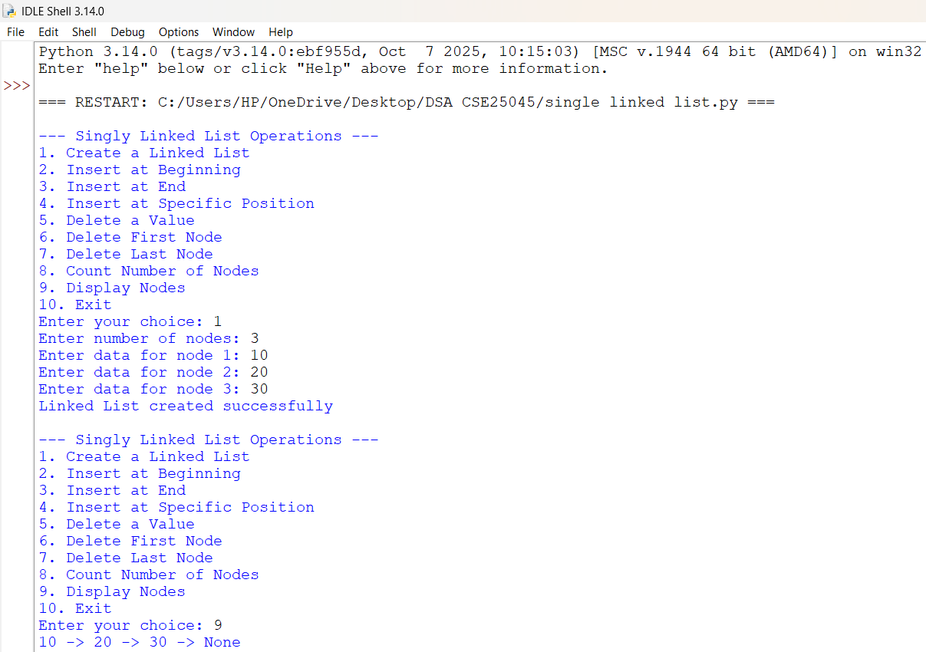
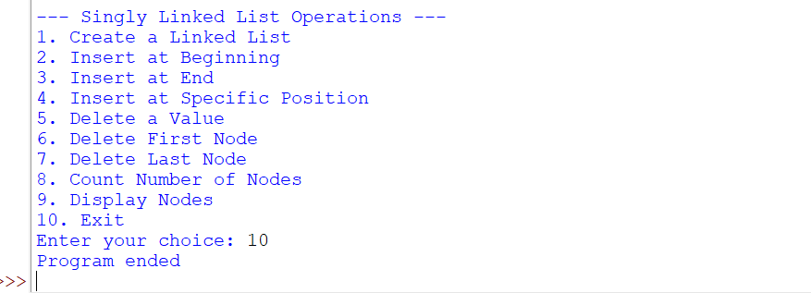

EXPLANATION:
1. class Node
- Defines a node of the Singly Linked List.
- self.data stores the value of the node.
- self.next stores the reference to the next node.
2. class LinkedList
- Defines the Linked List and its operations.
- self.head points to the first node of the list.
3. create()
- Creates n nodes using a for loop.
- Takes data from the user and calls insert_end() to add each node.
4. insert_begin()
- Creates a new node using Node(data).
- new.next = self.head links it to the current first node.
- Updates self.head to make the new node the first node.
5. insert_end()
- Creates a new node.
- Uses while temp.next to traverse to the last node.
- Connects the new node using temp.next = new.
6. insert_position()
- Inserts a node at a specific position.
- Traverses to the required location using a loop.
- Updates the next references to connect the new node correctly.
7. delete_value()
- Searches for a node containing the given value.
- Uses a while loop for traversal.
- Deletes the node by changing the appropriate next reference.
8. delete_first()
- Deletes the first node.
- Updates the head using:
self.head = self.head.next.
9. delete_last()
- Traverses to the second-last node.
- Sets temp.next = None to remove the last node.
- Also handles the special case of a single-node list.
10. count()
- Traverses the linked list using temp.
- Increments counter c for every node.
- Displays the total number of nodes.
11. display()
- Traverses the list from head until None.
- Prints the data of each node in linked list format.
12. Main Program
- ll = LinkedList() creates an object of the LinkedList class.
- while True creates an infinite loop to repeatedly display the menu.
- if-elif statements perform operations based on the user's choice.
- break terminates the loop and ends the program when Exit is selected.
ERROR TABLE:
S.NO | Error Obtained | Rectification
1. | Invalid insertion position. | Added position validation using if position < 1 and if temp is None.
2. | Value to be deleted may not exist. | Checked using if temp.next is None and displayed "Value not present".
3. |  | Used proper conditional statements and return statements to control program flow.
  Program may terminate unexpectedly during normal operations.

4b. AIM: Write a python program to implement a DLL which could perform the below operations by taking an input from the user.
1) create a DLL
2) Insert at beginning
3) Insert at the end
4) Insert at specific position
5) deletion at beginning
6) deletion at the end
7) deletion at the specific position
8) Count no. of nodes
9) display / traverse
10) exit
PROGRAM:
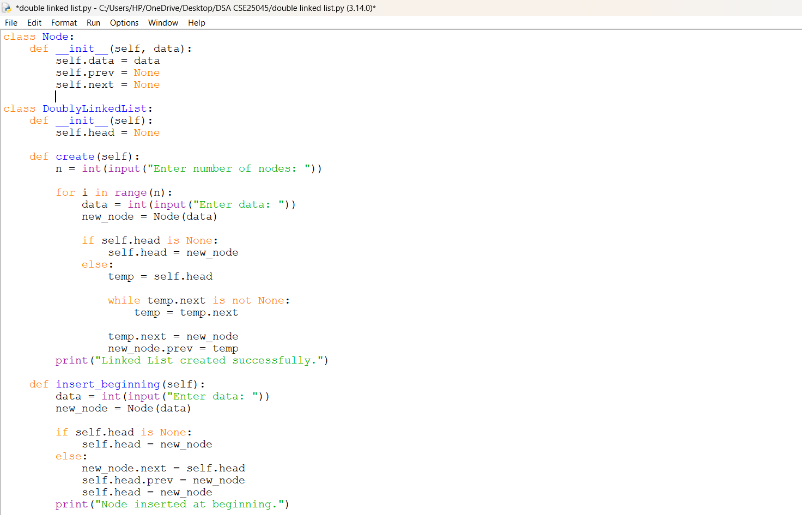
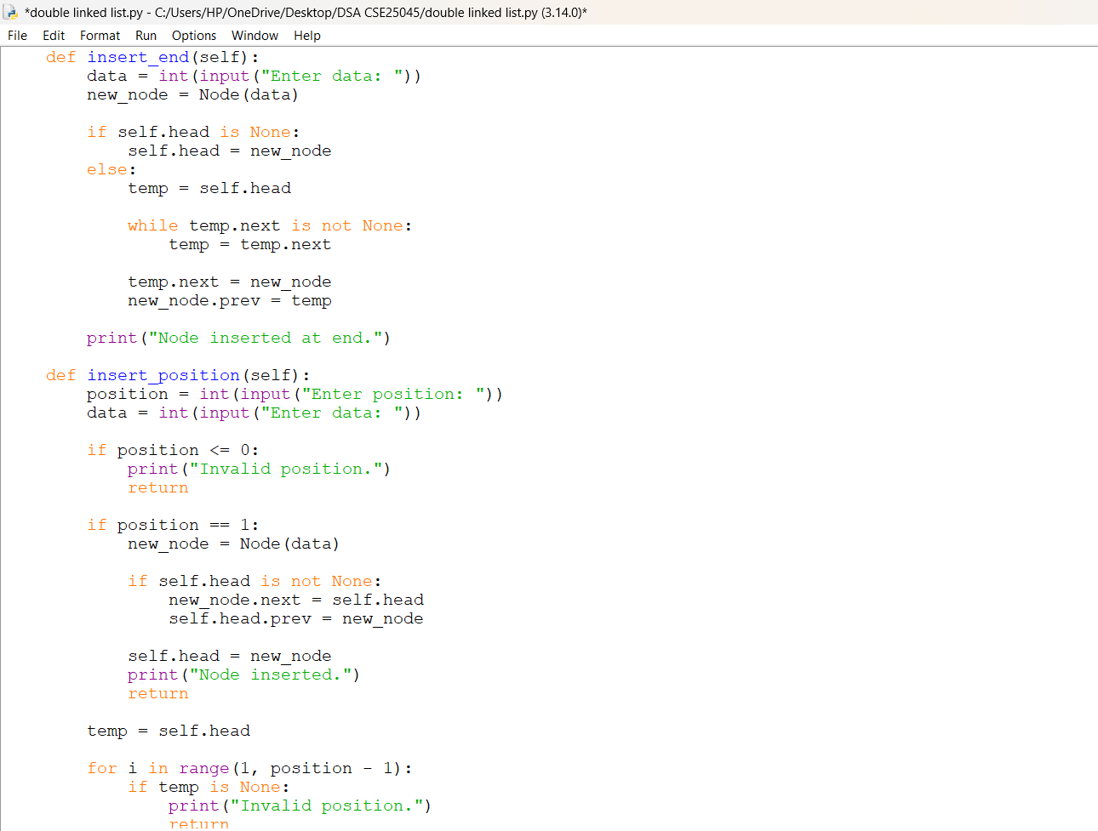
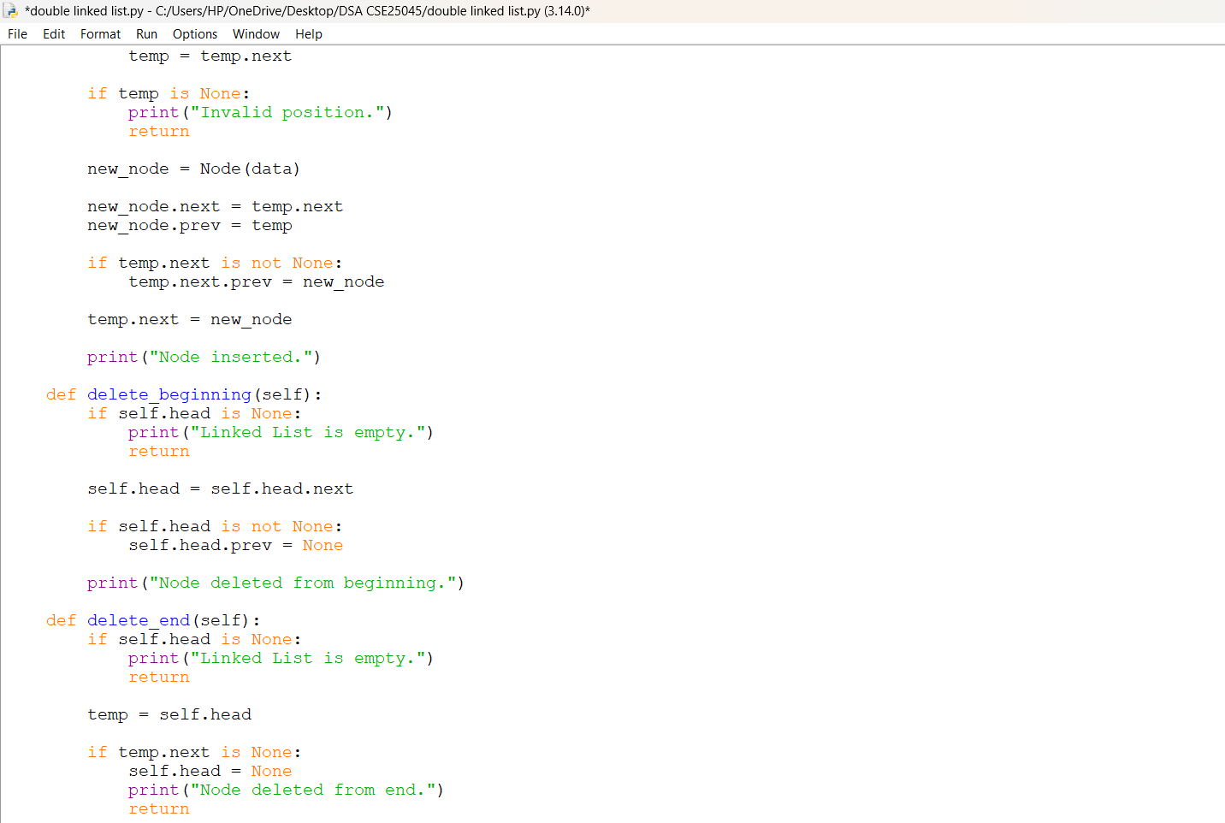
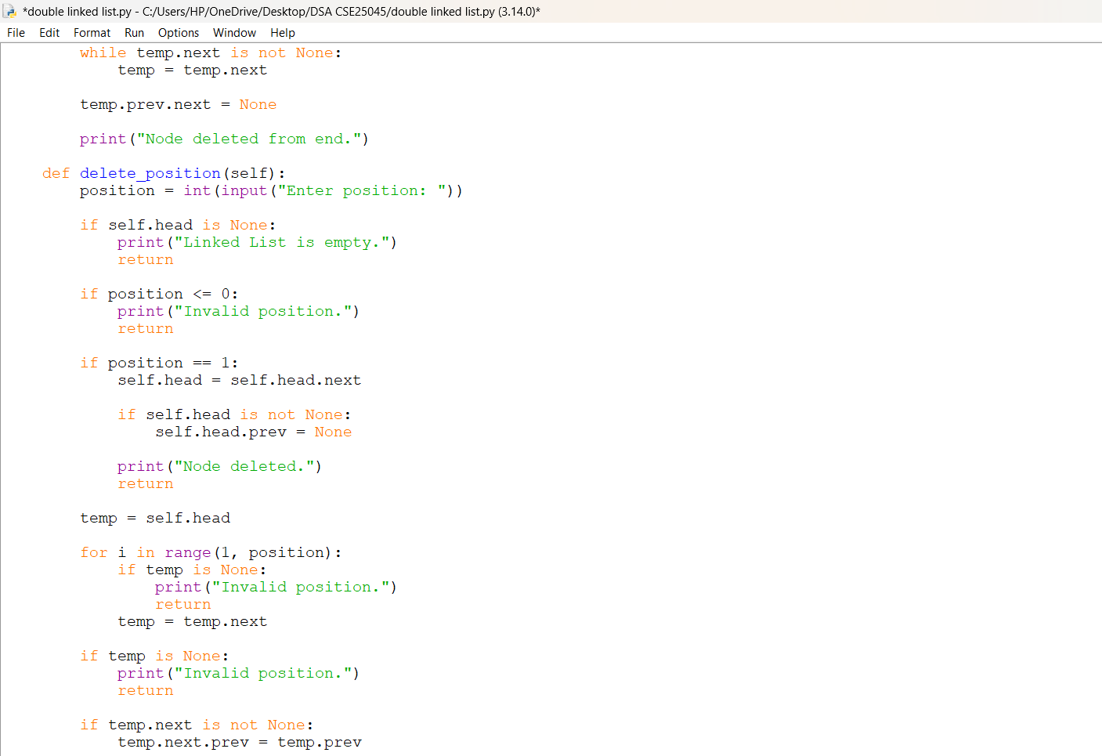
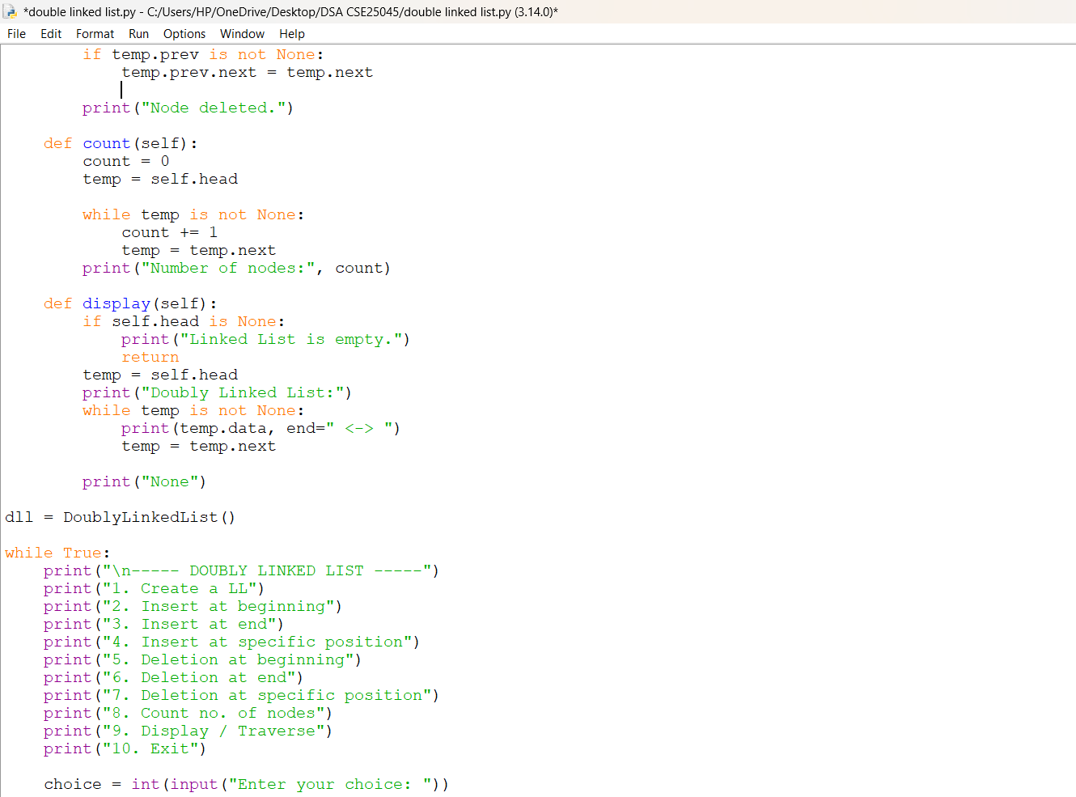
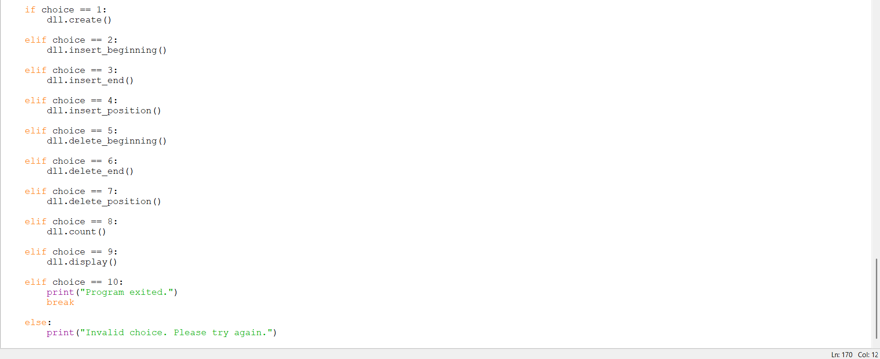
OUTPUT:
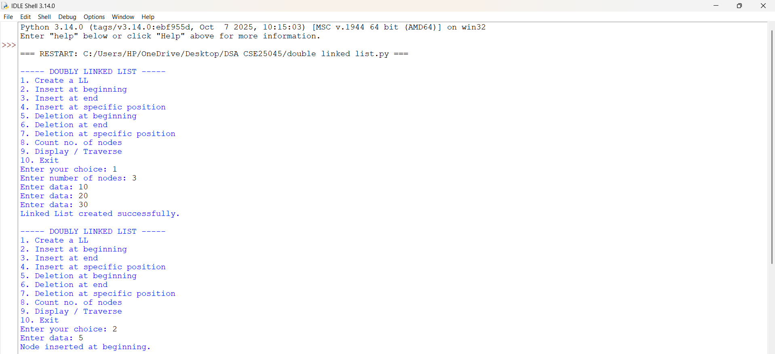
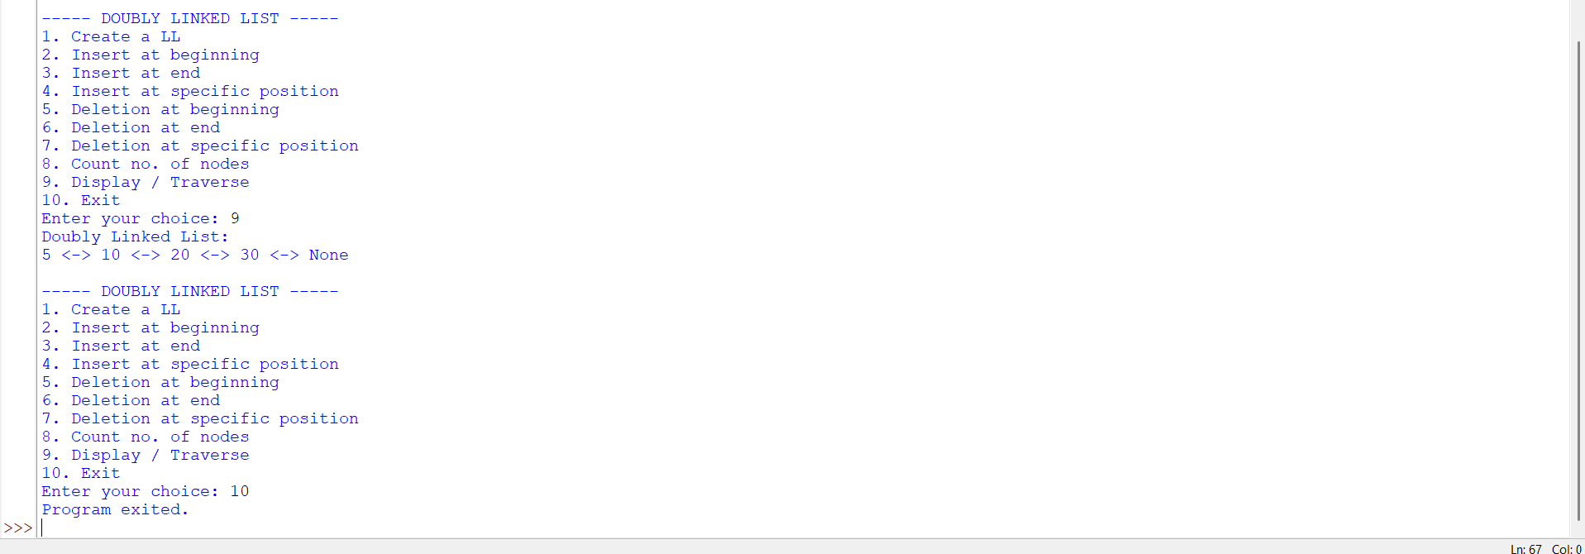
EXPLANATION:
- The program first defines a Node class to create nodes and initializes data, prev, and next for each node.
- The DoublyLinkedList class initializes an empty list by setting head to None.
- In create(), the user enters the number of nodes and their data. Each new node is added to the end of the list and connected in both directions.
- In insert_beginning(), a new node is created and connected before the current first node. The head is then changed to the new node.
- In insert_end(), the program starts from head, traverses to the last node, and attaches the new node after it.
- In insert_position(), the program traverses to the required position and places the new node between two existing nodes by updating their connections.
- In delete_beginning(), the first node is removed by moving head to the next node and making its prev pointer None.
- In delete_end(), the program traverses to the last node and removes it by disconnecting it from its previous node.
- In delete_position(), the program reaches the node at the given position and connects its previous and next nodes directly, removing the selected node.
- In count(), the program starts from head, visits every node using next, and increments count until the end is reached.
- In display(), every node is visited from the first node to the last node and its data is printed in the form 10 <-> 20 <-> 30.
- The main while True loop repeatedly displays all available operations and takes the user's choice.
- The if-elif statements call the appropriate function according to the selected option.
- When the user enters 10, the break statement stops the loop and terminates the program.

ERROR TABLE:
S.NO | Error Obtained | Rectification
1.
  AttributeError: 'NoneType' object has no attribute 'next' may occur when trying to access temp.next while the list is empty.
  Check whether self.head or temp is None before accessing next.
2. |  | Update both prev and next pointers whenever a node is inserted or deleted.
  Incorrect linking may occur during insertion or deletion if only one of the prev or next pointers is updated.

4c. AIM: Write a python program to implement a CLL which could perform the below operations by taking an input from the user.
1) create a CLL
2) Insert at beginning
3) Insert at the end
4) Insert at specific position
5) deletion at beginning
6) deletion at the end
7) deletion at specific positon
8) Count no. of nodes
9) display / traverse
10) display head and tail
11) exit
PROGRAM:
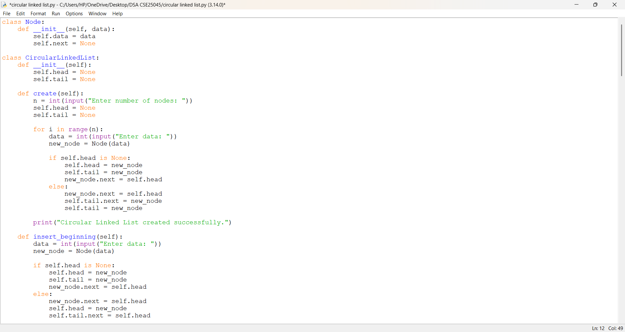
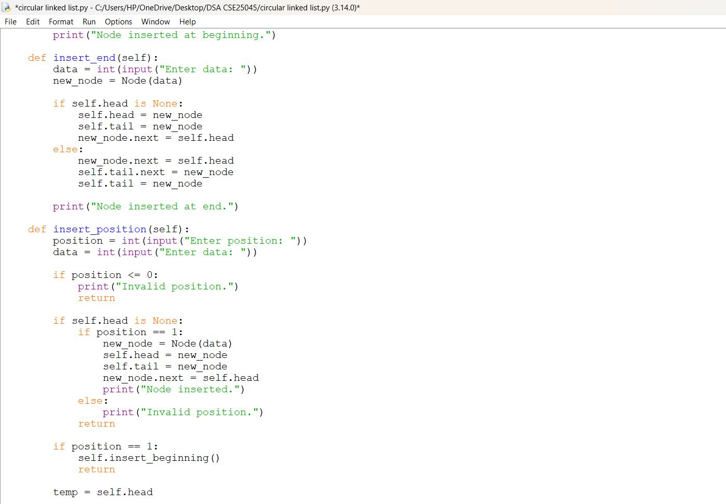
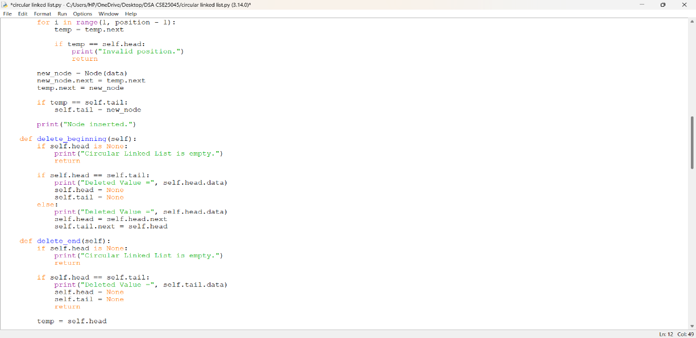
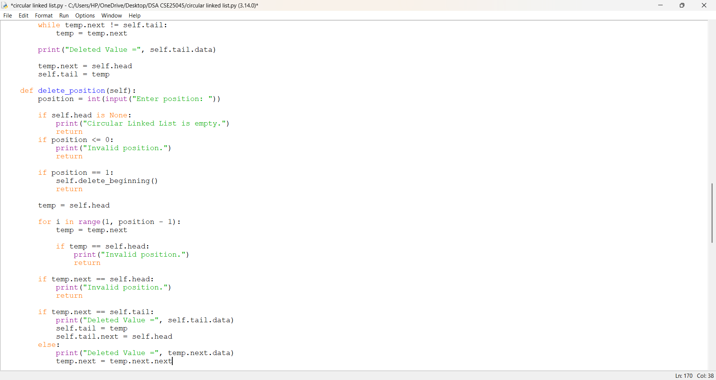
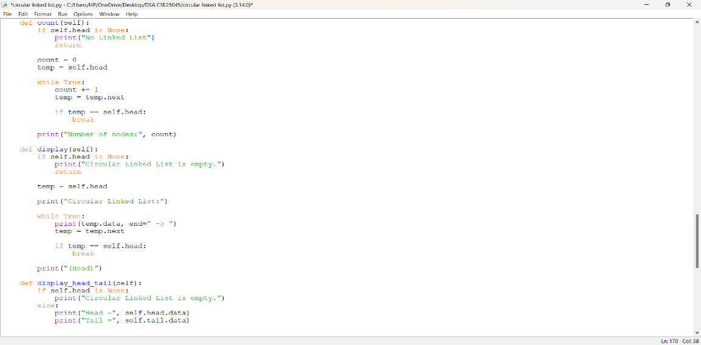
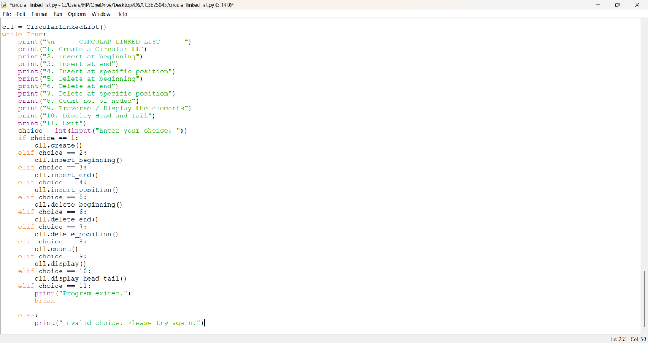

OUTPUT:
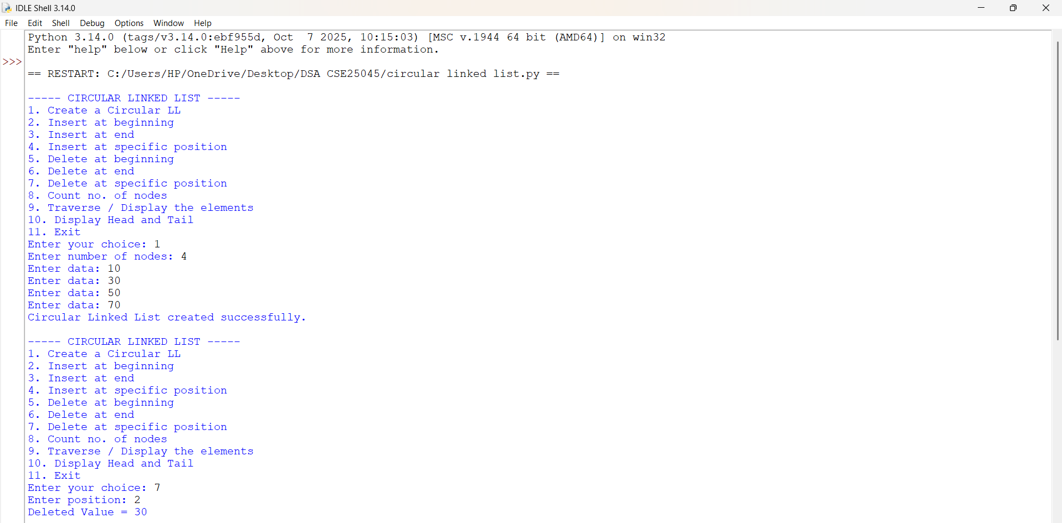
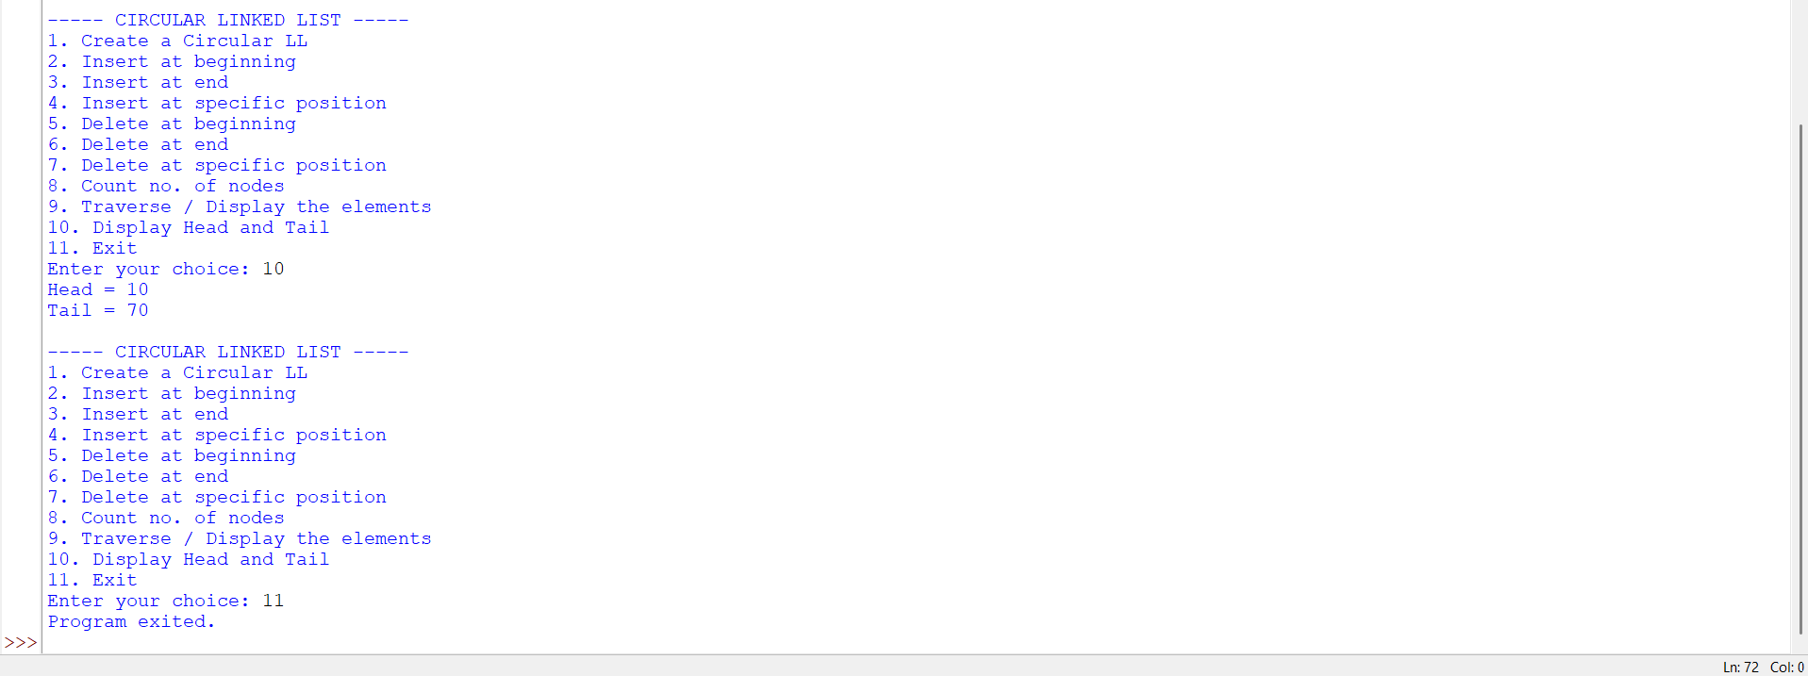

EXPLANATION:
- The program defines a Node class with data and next to store the value and link to the next node.
- The CircularLinkedList class maintains two references: head for the first node and tail for the last node.
- In create(), the user enters the number of nodes and their data. Each node is added to the list, and tail.next is always connected back to head.
- insert_beginning() creates a node before the current head and then updates tail.next so the circular connection is maintained.
- insert_end() adds a node after the current tail, makes it the new tail, and connects it back to head.
- insert_position() traverses the list up to the required position and inserts the new node between existing nodes. If inserted at the end, tail is updated.
- delete_beginning() removes the first node by moving head to the next node and reconnecting tail.next to the new head.
- delete_end() traverses to the node before tail, removes the last node, and makes that node the new tail.
- delete_position() finds the required node and bypasses it by changing the previous node's next. If the deleted node is the tail, tail is updated.
- count() starts from head and keeps traversing until it reaches head again, counting each node.
- display() prints every node starting from head and stops when the traversal reaches head again, avoiding an infinite loop.
- display_head_tail() directly prints the data stored in the head and tail nodes.
- The while True loop creates a menu-driven program where the user selects an operation using choice.
- The corresponding if-elif statements call the selected function.
- Selecting 11 executes break and terminates the program.
- The key feature of the code is that tail.next = head, which keeps the linked list circular.

ERROR TABLE:
S.NO | Error Obtained | Rectification
1. |  | Use if temp == self.head: break to stop traversal when the pointer reaches the head again.
  infinite loop during traversal/display because a circular linked list does not have a None at the end.
2. |  | Maintain self.tail.next = self.head after every insertion or deletion so that the last node always points back to the first node.
  Incorrect circular connection after insertion or deletion if tail.next is not updated.

WEEK – 5
5. AIM: Write a python program to implement a stack using an Array, Linked list. Implement the stack operations such as push, pop, peak and also display the stack elements.
PROGRAM: Stack using an Array
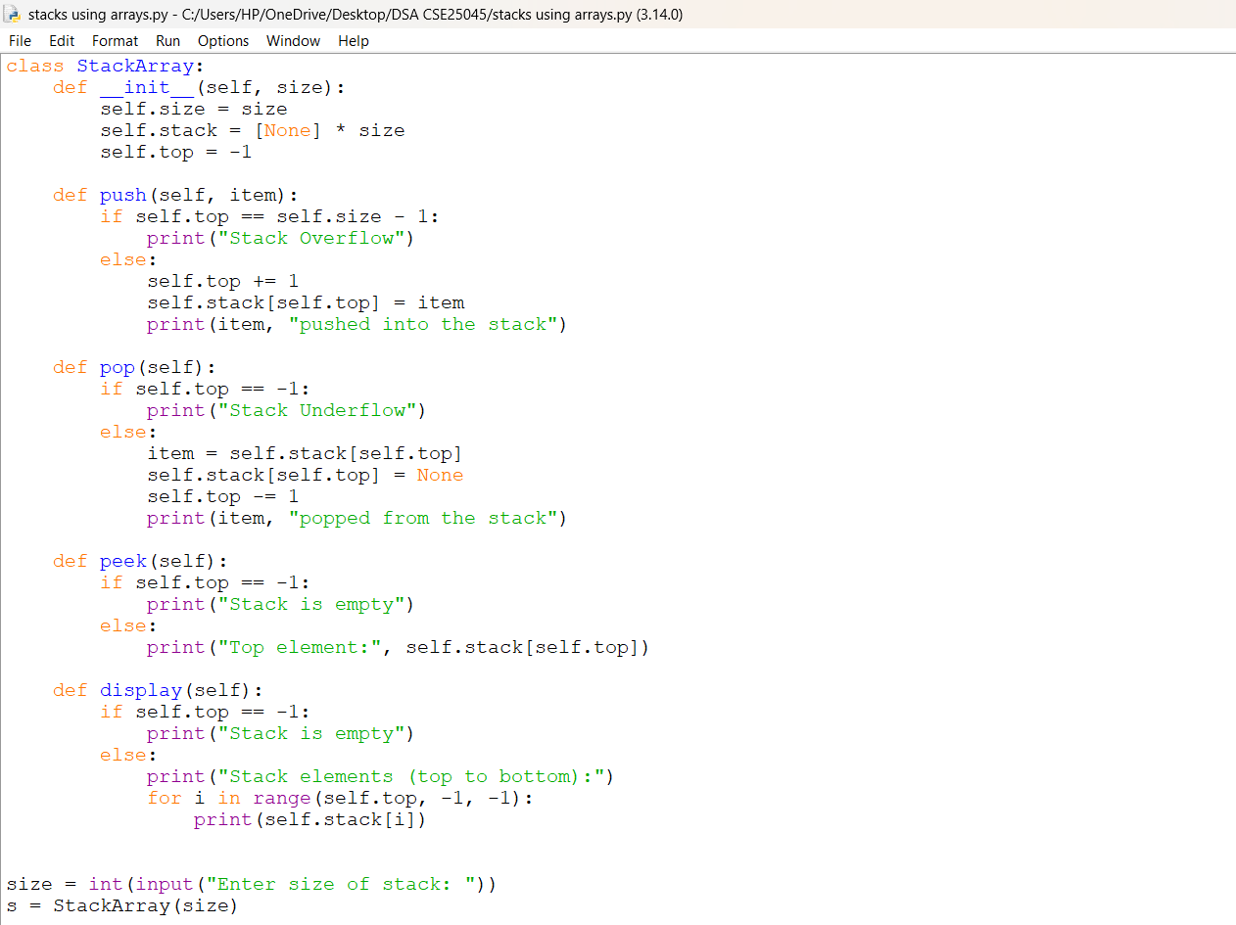
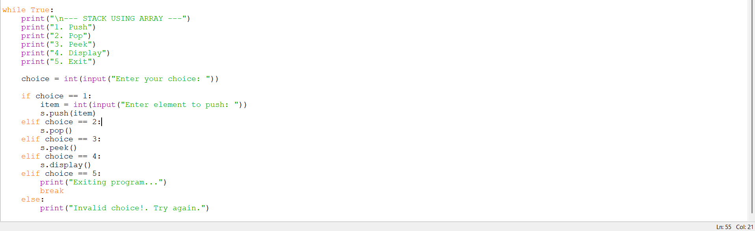

OUTPUT:
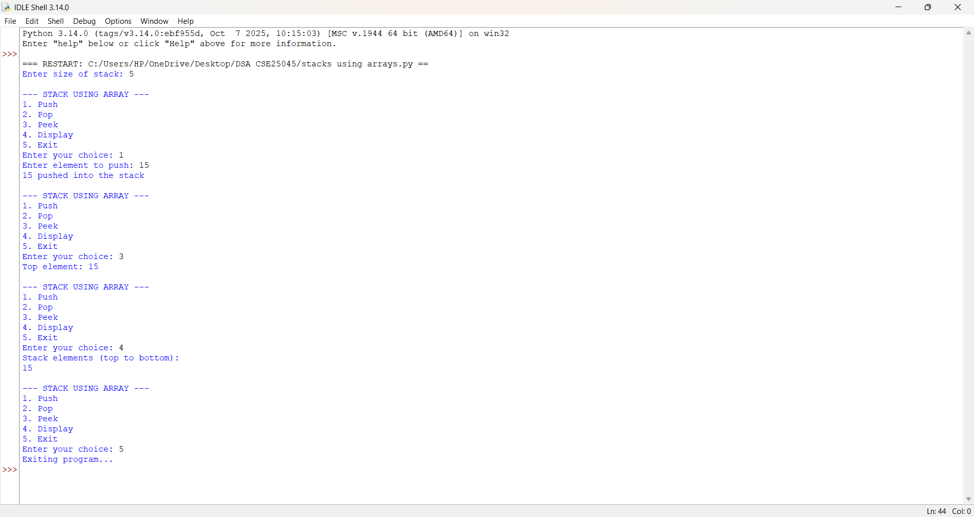
EXPLANATION:
- class StackArray: : Defines a class to implement the stack.
- __init__(size) : Creates the stack and sets its initial values.
- self.stack = [None] * size : Creates an array with empty positions.
- self.top = -1 : Sets top to -1 because the stack is initially empty.
- push(item) : Adds an element to the stack.
  - Checks if the stack is full.
  - Increases top by 1.
  - Stores the item at stack[top].
- pop() : Removes the top element.
  - Checks if the stack is empty.
  - Gets the element at stack[top].
  - Removes it by setting it to None.
  - Decreases top by 1.
- peek() : Shows the top element without removing it.
- display() : Uses a for loop to print elements from top to 0.
- size = int(input(...)) : Gets the stack size from the user.
- s = StackArray(size) : Creates a stack object.
- while True : Continuously displays the menu.
- choice : Takes the user's operation choice.
- LIFO principle : The last element pushed is the first element popped.

PROGRAM: Stack using an Linked List
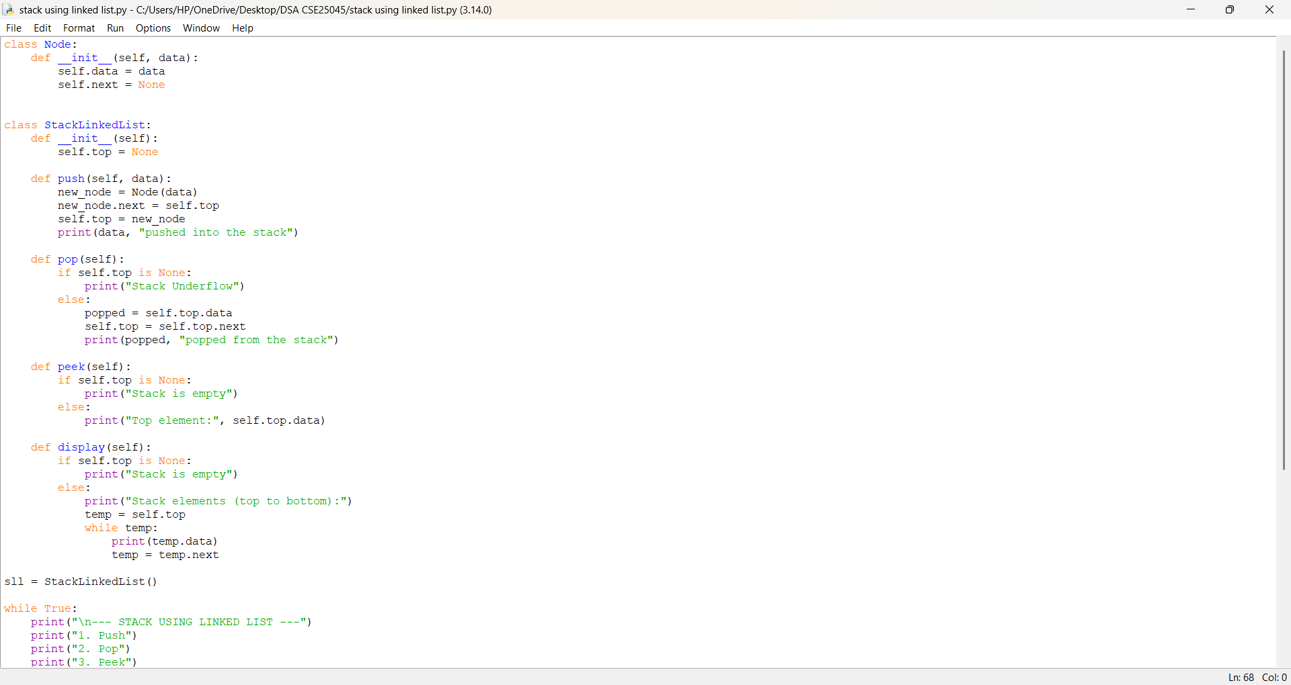
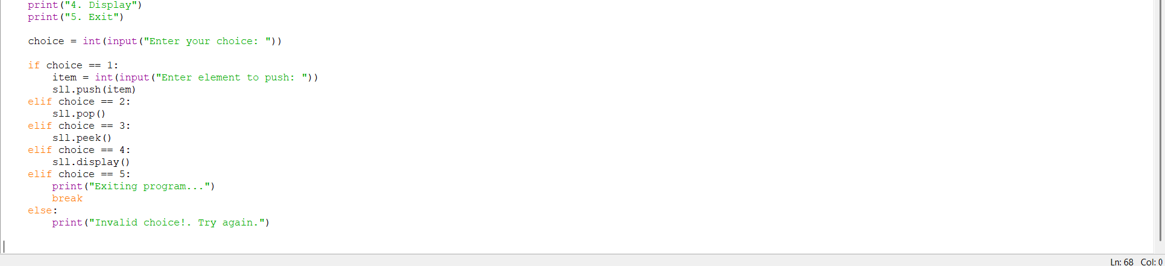
OUTPUT:
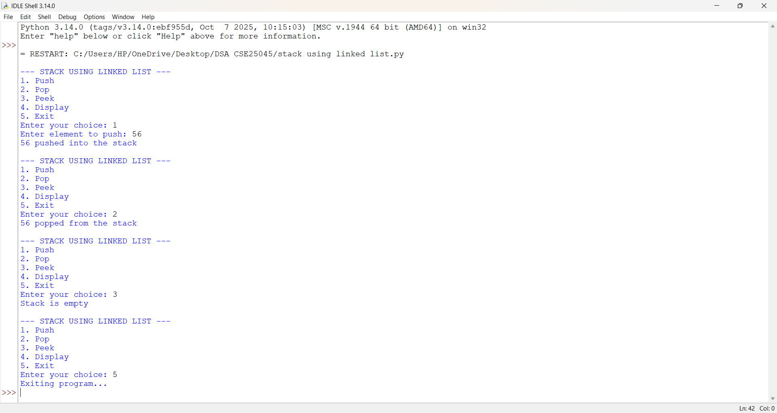
EXPLANATION:
- Node(data) : Creates a node and stores the element in data.
- next = None : Initially, the node has no link.
- top = None : Initializes an empty stack.
Push:
- new_node = Node(data) : Creates a new node.
- new_node.next = self.top : Links it to the current top.
- self.top = new_node : Makes it the new top.
- Process: Create : Link : Update top.
Pop:
- Checks self.top is None for underflow.
- popped = self.top.data : Gets the top value.
- self.top = self.top.next : Moves top to the next node.
- Process: Get value : Move top : Remove old top.
Peek:
- self.top.data : Displays the top value without removing it.
Display:
- temp = self.top : Starts from top.
- while temp : Traverses the nodes.
- temp = temp.next : Moves to the next node.
Main Program:
- sll = StackLinkedList() : Creates the stack.
- choice : Selects Push, Pop, Peek, Display, or Exit.
- while True : Repeats the menu.
- break : Exits the program.
- LIFO: Last inserted : First removed.

ERROR TABLE:
S.NO | Error Obtained | Rectification
1. |  | Check whether the stack is full before push() and empty before pop() using top.
  IndexError may occur if an element is accessed outside the array limit in the Array Stack.
2.
  AttributeError may occur in Linked List Stack if self.top.data is accessed when top is None.
  Check if self.top is None before performing pop() or peek().

WEEK – 6
6a. AIM: Write a python program to implement queue and its operations such as enqueue, dequeue, peek, display with a menu driven approach implement using array, linked list.
PROGRAM: Using array
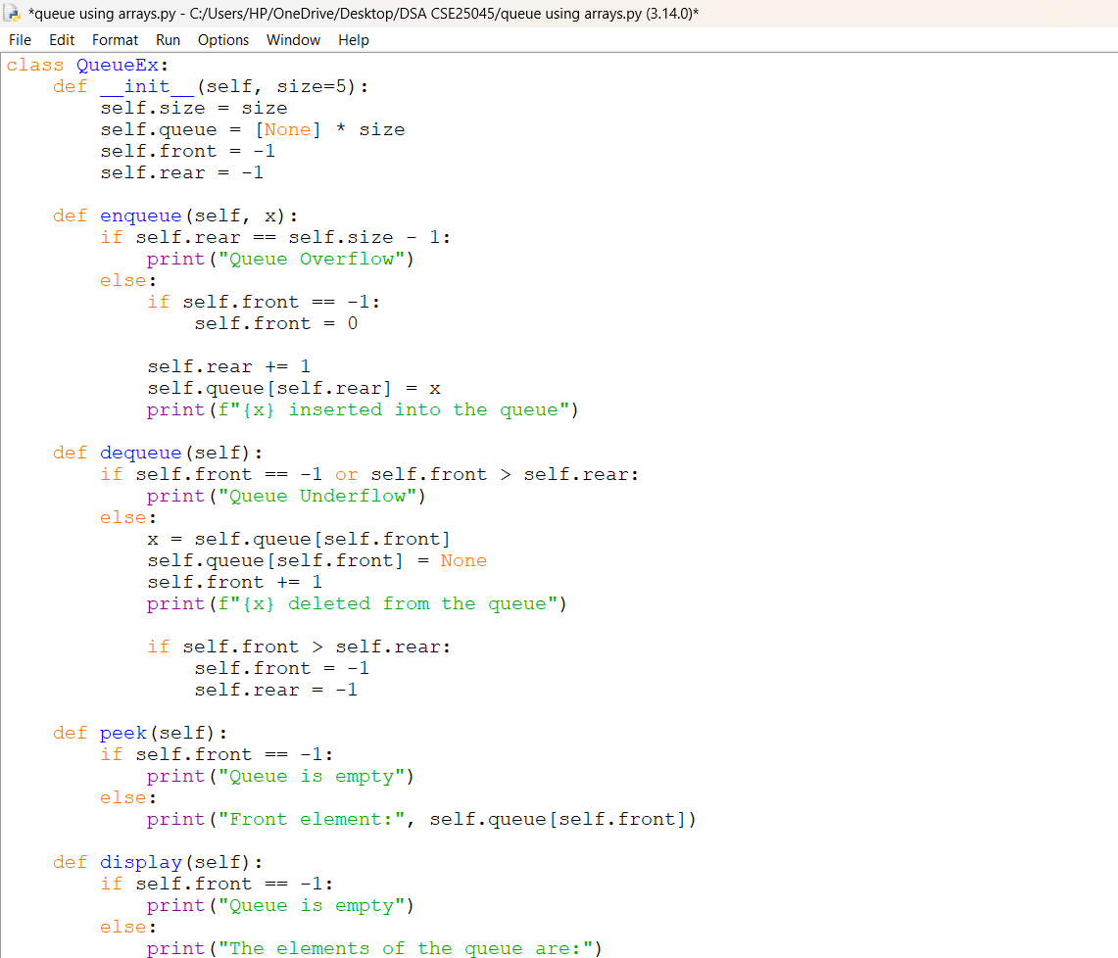
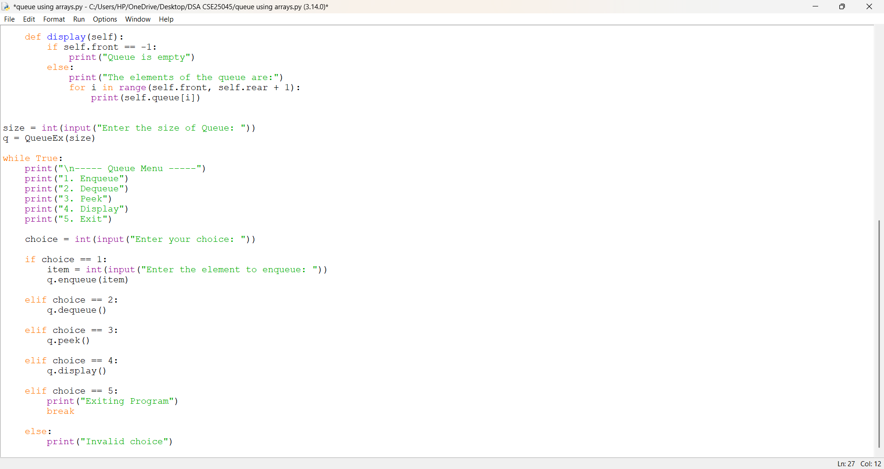

OUTPUT:
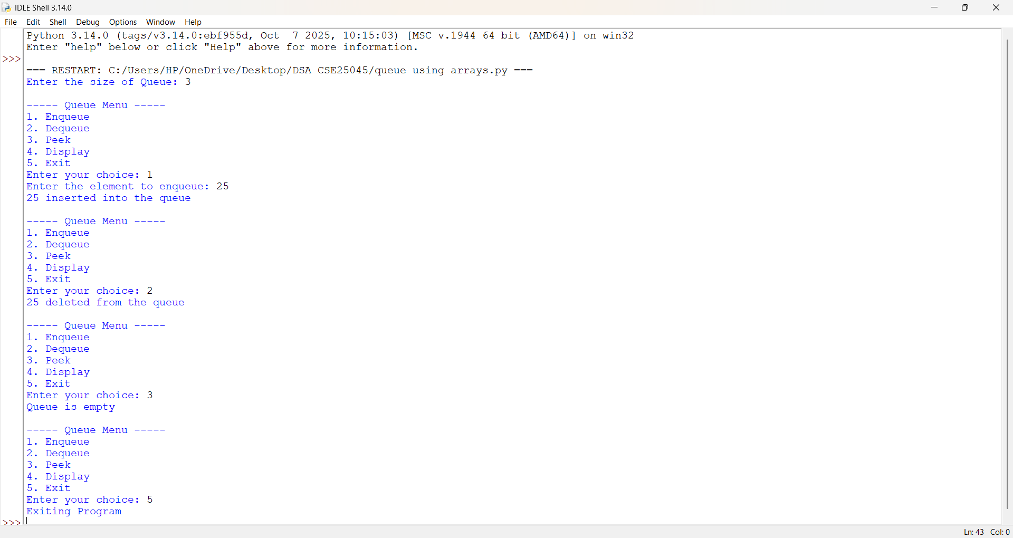

PROGRAM: Using linked list
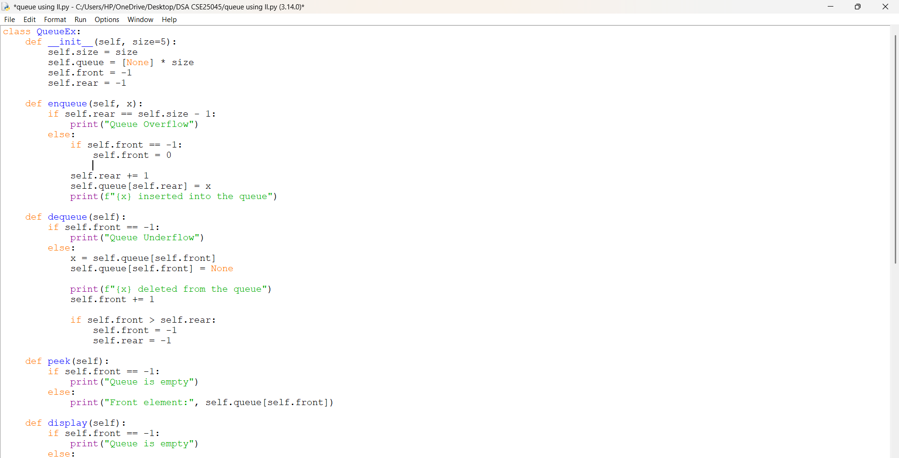
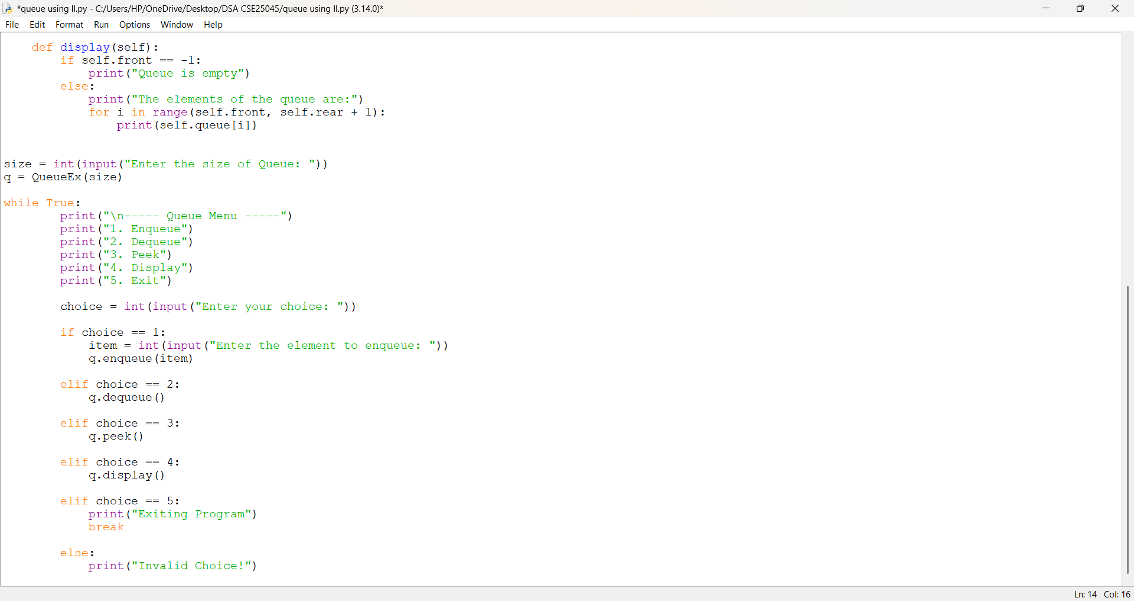
OUTPUT:
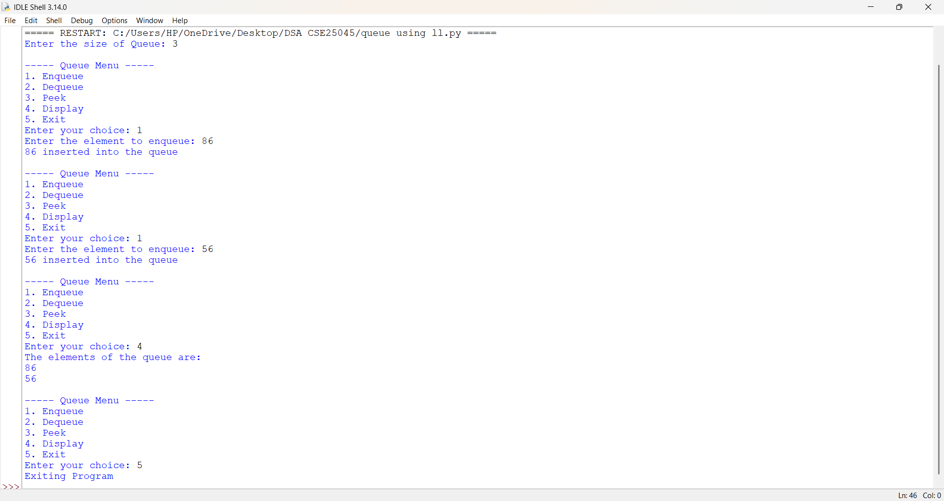
EXPLANATION:
- class QueueEx: Creates a class named QueueEx for implementing the queue.
- __init__(self, size=5): Constructor that initializes the queue with a default size of 5.
- self.size = size : Stores the user-given queue size.
- self.queue = [None] * size : Creates a list of the given size and initializes all positions with None.
- self.front = -1 : Initializes front to indicate that the queue is empty.
- self.rear = -1 : Initializes rear to indicate that no element is present.
enqueue()
- if self.rear == self.size - 1: Checks whether rear has reached the last position.
- self.front = 0 : Sets the front position when inserting the first element.
- self.rear += 1 : Increases rear to the next position.
- self.queue[self.rear] = x : Stores x at the rear position.
- print() : Displays the insertion message.
dequeue()
- if self.front == -1 or self.front > self.rear: Checks whether the queue is empty.
- x = self.queue[self.front] : Stores the front element in x.
- self.queue[self.front] = None : Removes the front element from the list.
- self.front += 1 : Moves front to the next position.
- if self.front > self.rear: : Checks whether all elements have been deleted.
- self.front = -1 and self.rear = -1 : Resets the queue to the empty state.
peek()
- if self.front == -1: Checks whether the queue is empty.
- self.queue[self.front] : Accesses and displays the front element without deleting it.
display()
- if self.front == -1: Checks whether the queue is empty.
- range(self.front, self.rear + 1) : Traverses the queue from front to rear.
- print(self.queue[i]) : Displays each queue element.

ERROR TABLE:
S.NO | Error Obtained | Rectification
1. |  | Check if self.rear == self.size - 1 before inserting an element.
  Queue Overflow occurs when the queue is full.
2. | Queue Underflow occurs when the queue is empty. | Check if self.front == -1 or self.front > self.rear before deleting an element.

6b. AIM: Write a python program to implement queue and its operations such as enqueue, dequeue, peek, display with a menu driven approach implement using circular linked list.
PROGRAM:
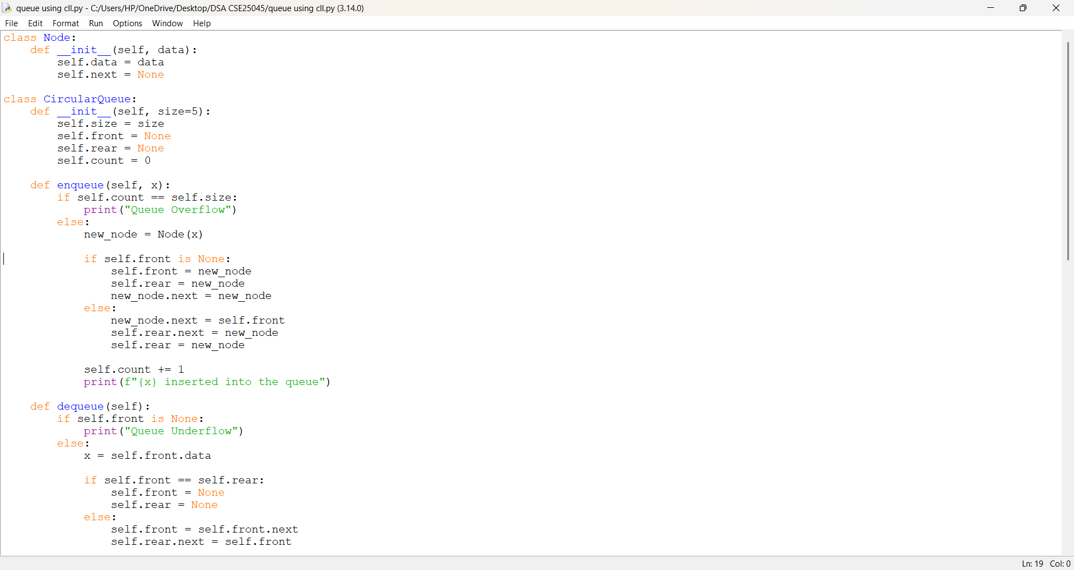
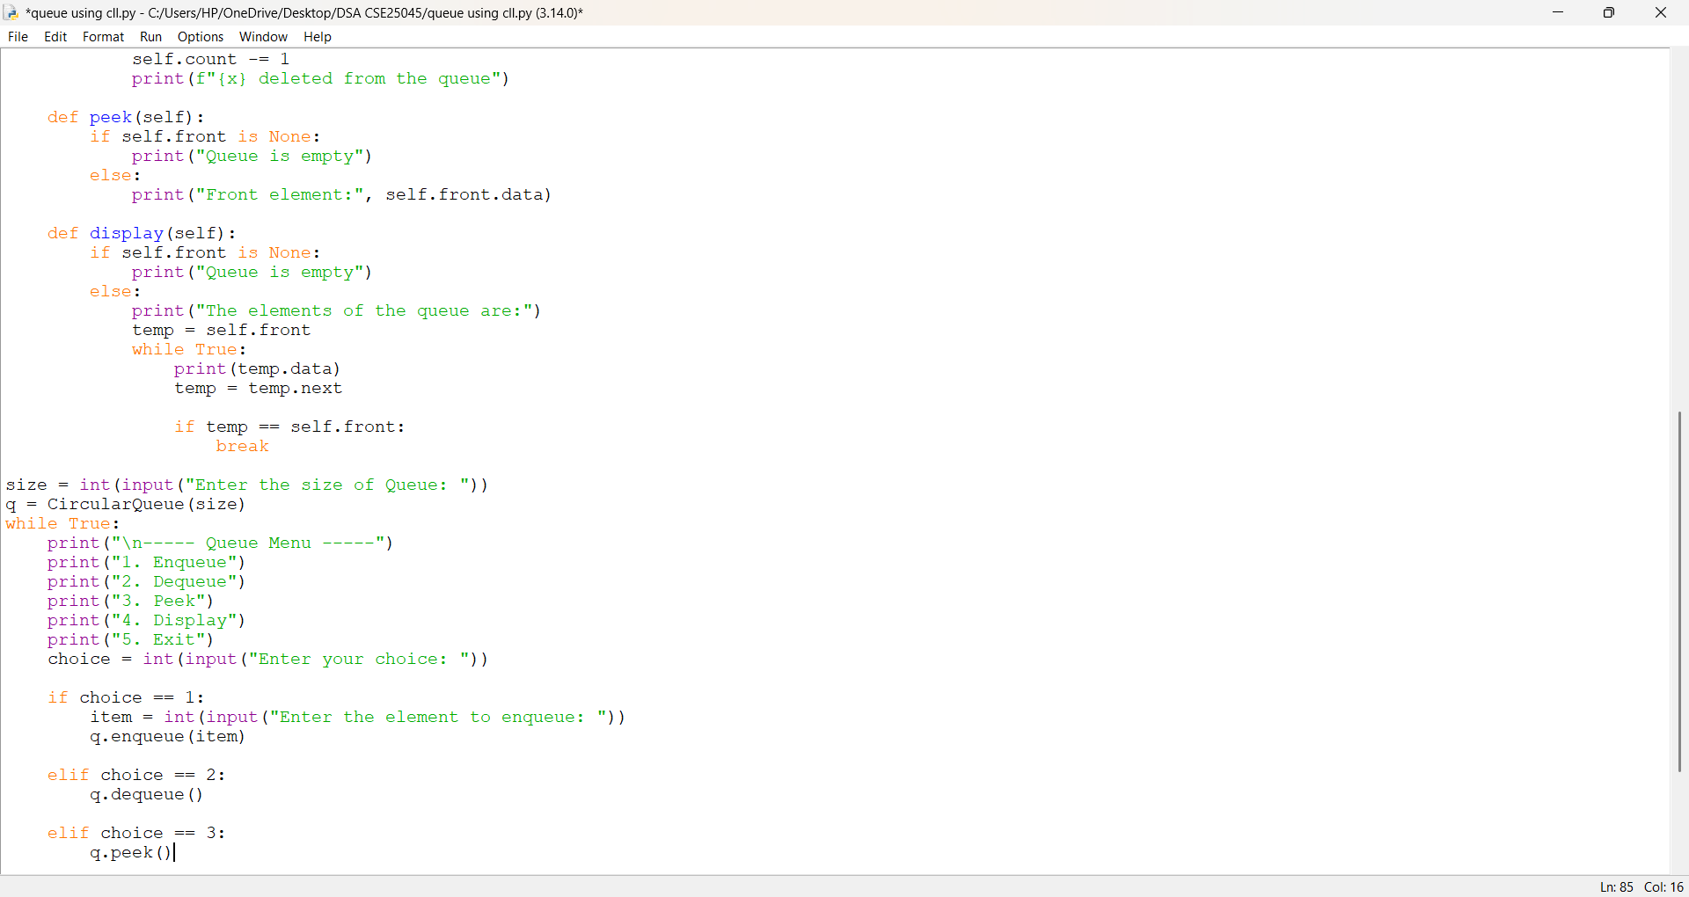
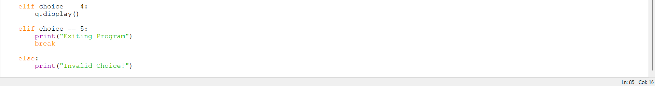
OUTPUT:
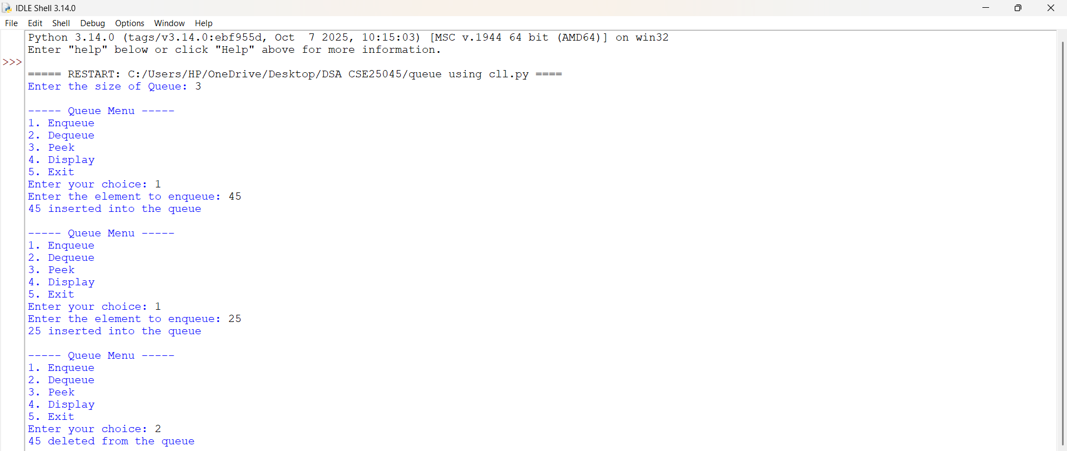
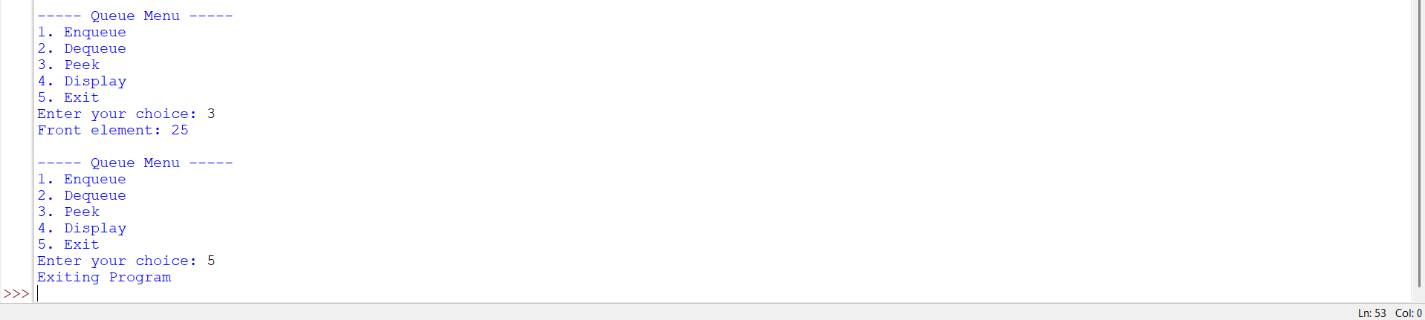
EXPLANATION:
1. Node Linking
- self.next = None : Initializes the node link as empty.
- new_node = Node(x) : Creates a new node with the given data.
- new_node.next = new_node : Makes the first node point to itself, forming a circular link.
2. Circular Connection During Enqueue
- new_node.next = self.front : Connects the new node to the first node.
- self.rear.next = new_node : Connects the current last node to the new node.
- self.rear = new_node : Updates the last node to the newly inserted node.
3. Circular Connection During Dequeue
- self.front = self.front.next : Moves front to the next node.
- self.rear.next = self.front : Reconnects the last node to the new front node.
- if self.front == self.rear: : Checks whether only one node exists.
- self.front = None : Removes the only node by clearing the front reference.
- self.rear = None : Clears the rear reference.
4. Circular Traversal
- temp = self.front : Starts traversal from the first node.
- temp = temp.next : Moves to the next linked node.
- if temp == self.front: : Detects that traversal has returned to the first node.
- break : Stops traversal after one complete circular cycle.
5. Node Data Access
- self.front.data : Accesses the data stored in the front node.
- temp.data : Accesses the data of the current node during traversal.
ERROR TABLE:
S.NO | Error Obtained | Rectification
1.
  new_node.next is not connected to front, breaking the circular link.
  Set new_node.next = self.front.
2. |  | Update self.rear.next = new_node during enqueue and self.rear.next = self.front during dequeue.
  self.rear.next is not updated after insertion or deletion.

